**MyTomorrow App**

**Cincinnati Public Schools**

**Mobile App and Website Manual**

**Version 3.0**

**Table of Contents**

1 Architecture 3

1.1 Architecture flow of Mobile (Xamarin App) 3

1.2 Architecture flow of .Net Web application: 3

1.3 Architecture flow of Drupal Web application: 4

1.4 Web Service (.NET Web API): 4

1.5 Database Schema Structure and Relations: 4

2 Mobile App: 5

2.1 Logging in: 5

2.2 Student Login 7

2.3 Teacher Login 15

3 Student & Teacher Website 24

3.1 Logging in 24

3.2 Student Login 27

3.3 Teacher Login 43

3.4 Logging Out: 53

4 Admin 53

4.1 Logging in: 53

4.2 Admin Dashboard: 54

4.3 Notifications: 55

4.4 Deleting Newsfeeds (Posts) 56

4.5 Menu 57

4.6 Newsfeed 57

4.7 Students: 63

4.8 Hall Pass 66

4.9 Rewards: 69

4.10 Help 71

5 User Management: (Future Implementation) 73

# Architecture

The CPS application is accessible via Mobile developed in Xamarin and Web Application developed using Microsoft .Net for Student / Teacher and an admin site that was developed using Drupal Content Management System. The Web API calls are developed in C# and are consumed in each of the mobile, web and Admin sites.

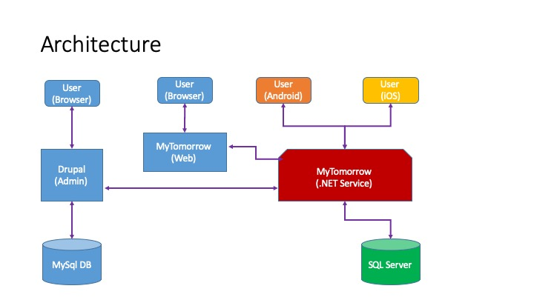

## Architecture flow of Mobile (Xamarin App)

The mobile application follows Model-View-ViewModel (MVVM) pattern in Xamarin forms. It contains service, interfaces and classes required to perform different tasks in the mobile application.

There are 2 different projects for Android and iOS wherein 90% of the Xamarin code is shareable between both mobile versions and any version specific code shall be overridden in each of the Android and iOS Projects. By using dependency service, custom renderer, etc., we maintain specific platform related code in the projects.

## Architecture flow of .Net Web application:

We are using .NET MVC pattern for the web application. MVC is a three-layer development architecture used for web application development. Model includes all the data and its related logic, View presents data to the user or handles user interaction and the Controller acts as an interface between Model and View components.

We are using Google OAuth Authorization for user login and using .NET API service calls as the intermediate between web / mobile Application and Database. Web API will take care of all the data related transactions.

## Architecture flow of Drupal Web application:

Admin sites was developed using Drupal Content Management System with MySQL database as the backend. Drupal has inbuilt Authentication manager service which helps to logging into website and will connect to the main application content through .Net web API calls for the data transactions.

## Web Service (.NET Web API):

We are using .NET web API calls as web Service calls to handle all the data base related transactions like saving, retrieving and modifications of the data and is an ideal platform for building Restful services.

## Database Schema Structure and Relations:

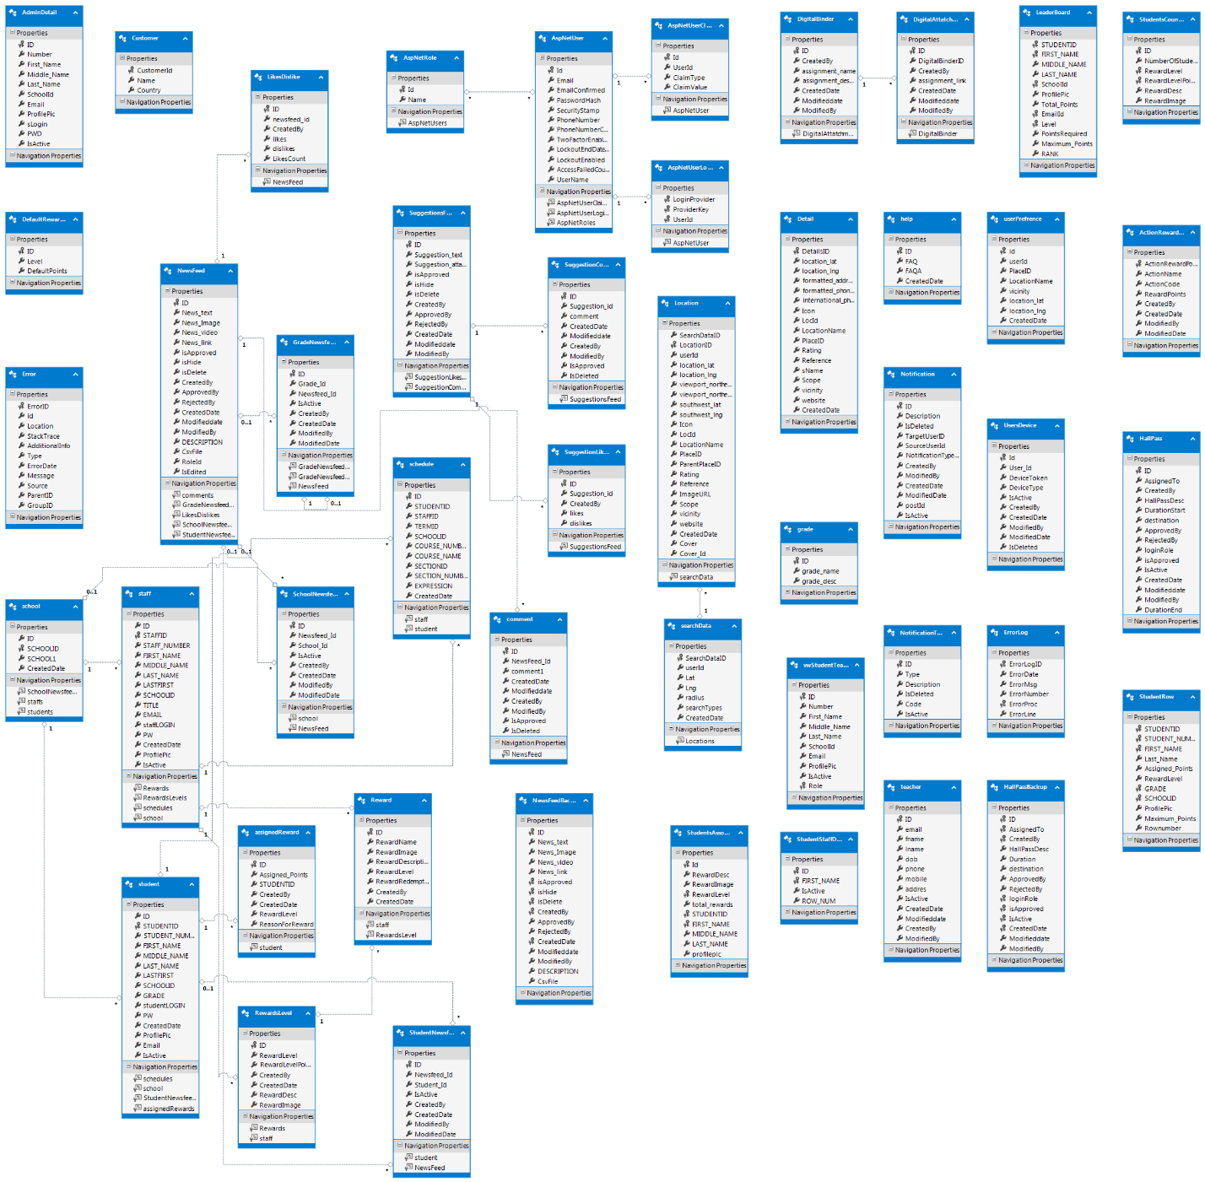

# Mobile App:

## Logging in:

To log in to the Cincinnati Public Schools mobile app as a Student or Teacher, perform the following steps:

* Click on the **Student** or **Teacher** button from the log in screen.
* After selecting the appropriate button, you will be redirected to the Sign in with Google screen.
* Click the Sign in with Google button. You will be redirected to the Choose an Account screen.
* On this screen, select an existing account or create a new account. Provide the password when asked for.
* After entering a valid password, you will be redirected to the Home page of the CPS app.

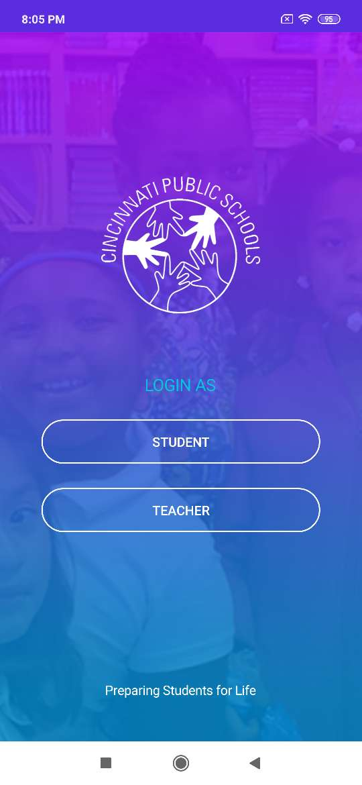 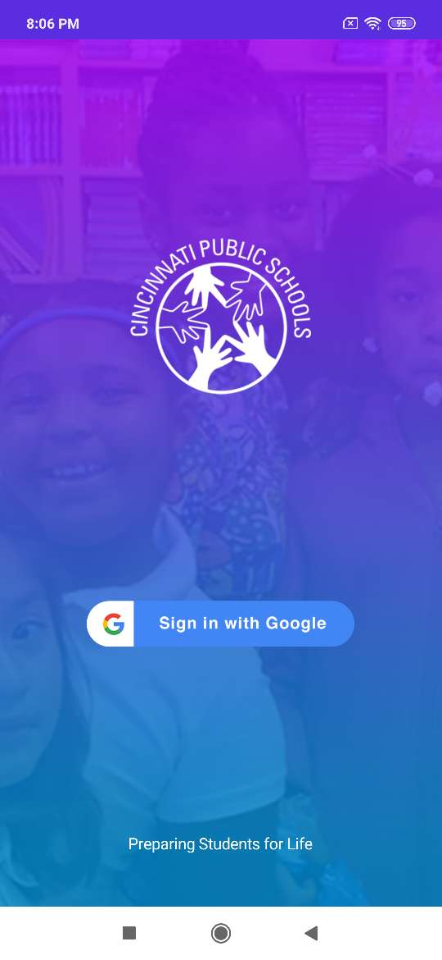 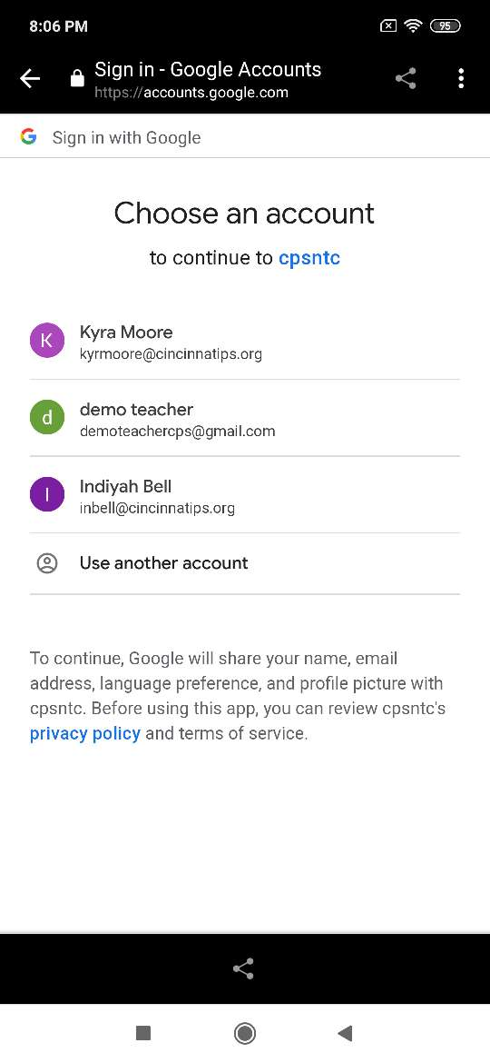

## Student Login

### Home Page

When you log in as a Student, you can view the News Feeds posted by Students, Teachers or Admin users on your Home page. You can post your post which can be a piece of Text, Pictures, Videos etc. You can also like posts, comment on posts, edit your post, delete your post etc.

**Note:** There are some rules and regulations for a student while posting a new post or when commenting on an existing post. A student cannot post any objectionable pictures, videos etc. All the posts made by Students need to be approved by an approver before being posted on the app. The approver can approve or reject Students’ posts.

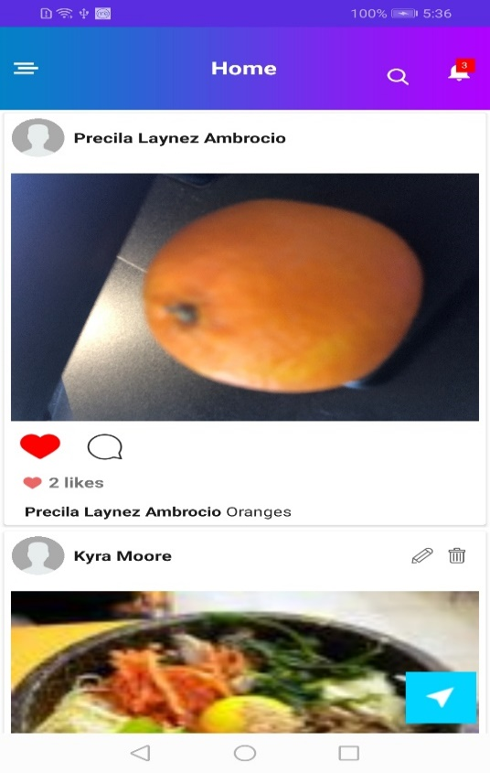 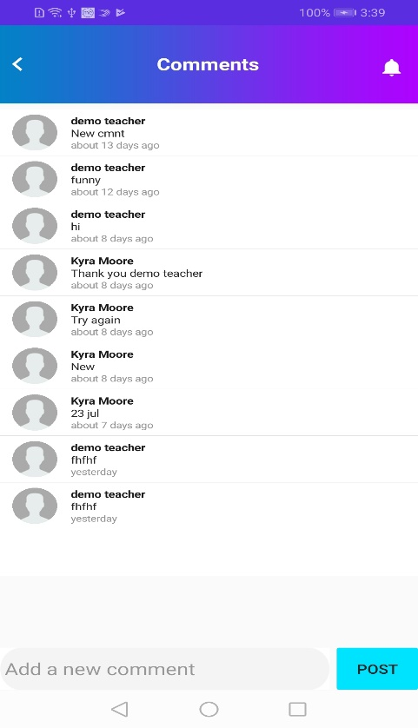

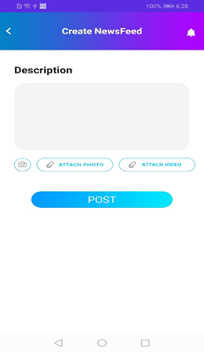 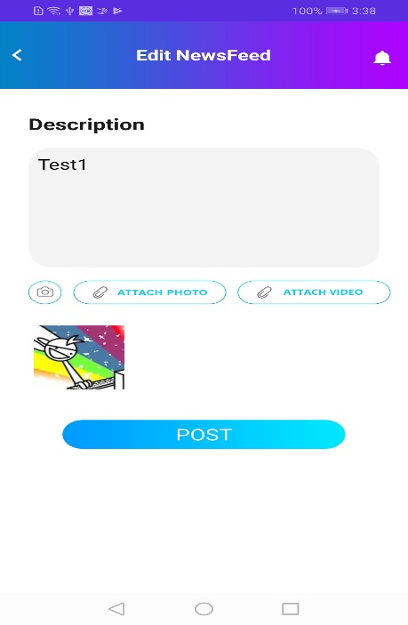 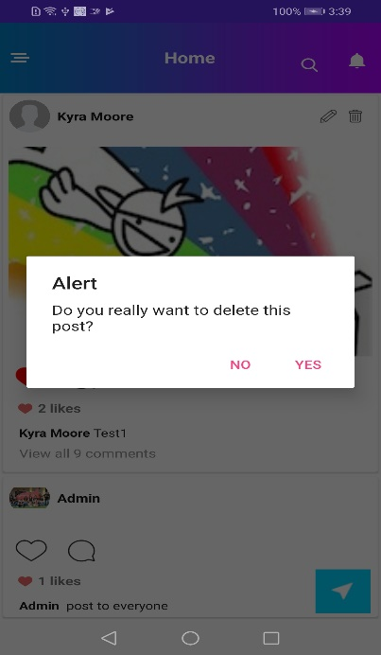

### Search:

Students can search for information on the app based on certain key words. There is a **Search** text box available at the top of the Home page. They can type in their keyword and the search result will be displayed below the **Search** text box based on the t keyword typed in .

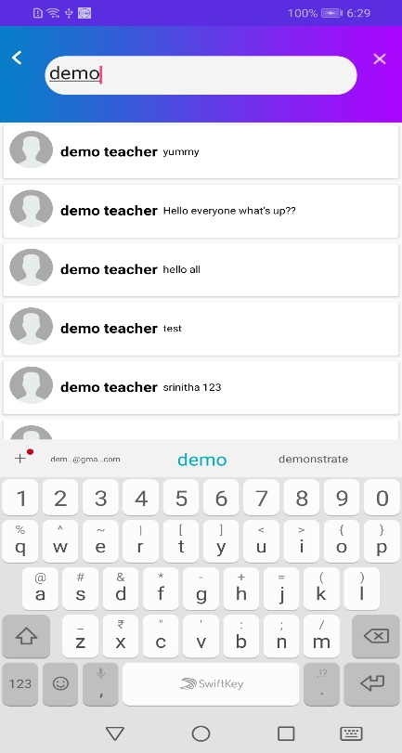

### Notifications:

The Notification page displays all the notifications such as the likes or comments made on your post, notifications when the hall pass is approved, etc. This page will display all the updates related to Students. You can click on any notification to access the details of that particular notification.

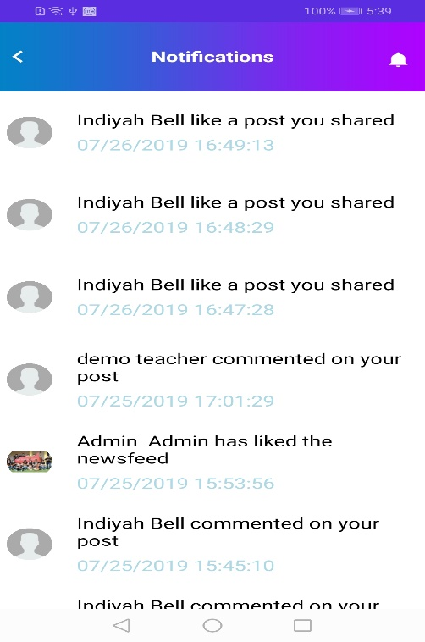 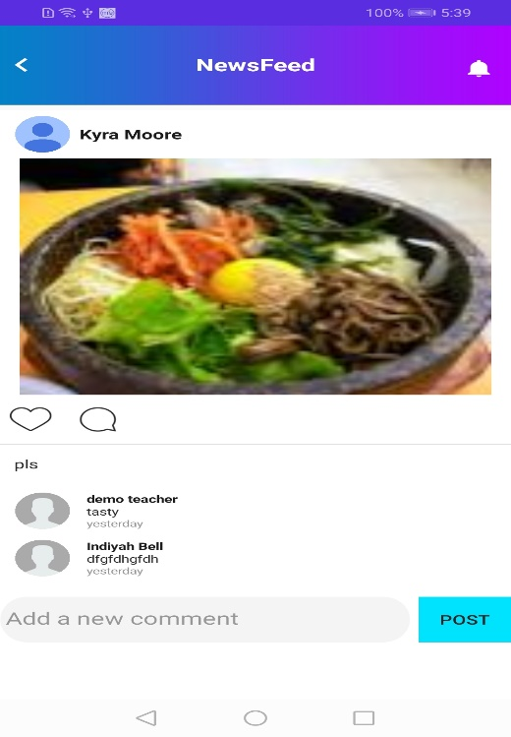

### Menu:

There is a **Menu** icon displayed at the top left corner of the Home page. You can click on this icon to view the list of menu options available from which you can select the menu you want and navigate to that particular page.

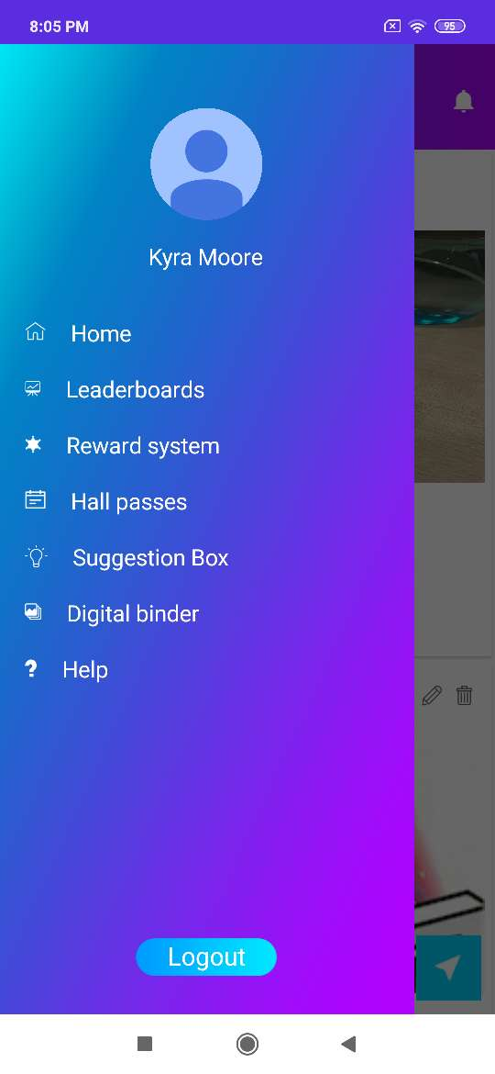

### LeaderBoards:

The Leaderboards page displays the details of the logged in Student. Details such as Rank, Points, Levels etc. are displayed. This page also displays the number of points required to reach the next levels. You can filter these details by clicking the **My School** toggle button.

**Note:** If the **My School** toggle button is enabled after logging in, then you can view only the details of the students belongs to your own school and if the toggle button is disabled, you can view the details of all the students of all the schools.

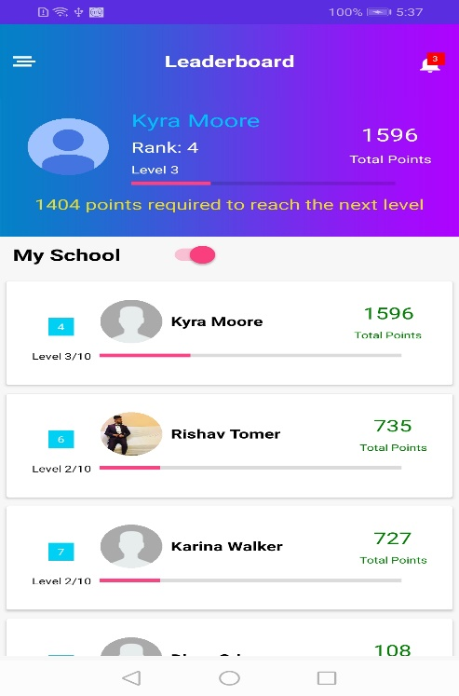 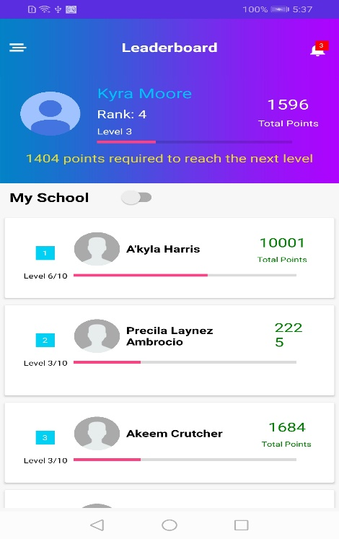

### Rewards System:

The Rewards System page displays the details of the logged in student such as Total Points, Rank etc. This page contains two buttons **Redeem my Points** and **How to Earn Points**. You can click the **Redeem my Points** button to redeemyour reward points. You can click the **How to Earn Points** button to get help on how to earn points.

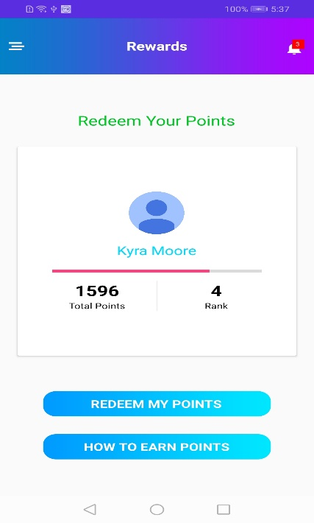

### Hall Passes:

The Hall Passes page consists of two tabs. They are **Request a hall pass** tab which displays all the hall pass requests along with the status of the respective hall pass and the **My Passes** tab which displays all the hall passes requested by the logged in user along with details such as Name, Valid From, Expires On, Description, Destination, Approved by etc.

#### Adding a new Hall Pass

* You can add new a hall pass by clicking the **Add Hall Pass** button displayed at the bottom right corner of the Request a hall pass screen.
* You will be redirected to the Add Pass screen after clicking on this button. On this screen, you need to fill in information such as Requesting teacher’s name, Reason, Destination, Start Date Time, End Date Time etc.
* Then click the **Submit** button at the bottom of the screen. After clicking this button, a hall pass request will be generated and the selected teacher will get a notification asking for the approval or rejection of that hall pass.

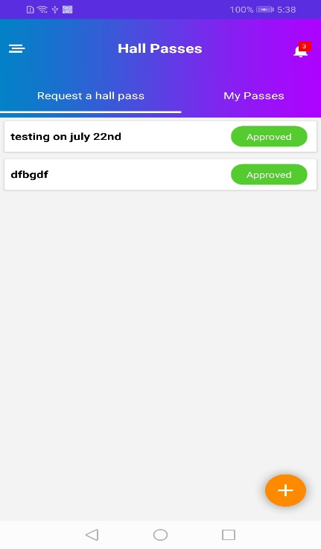 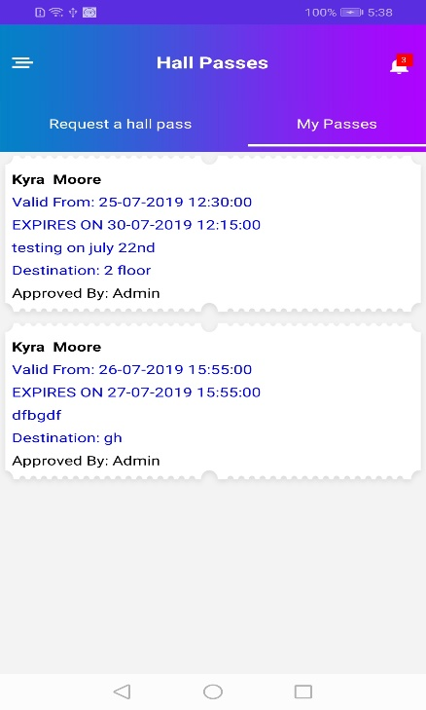 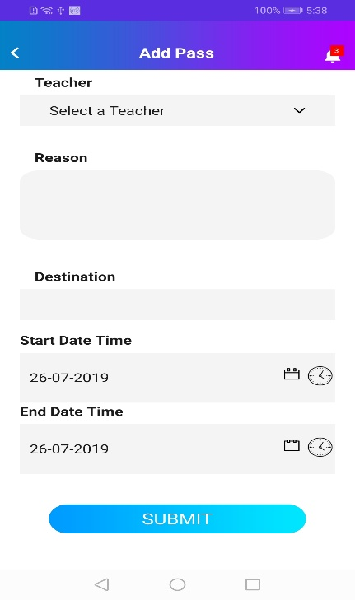

### Suggestion Box:

The Suggestion Box page for students has three tabs; **Suggestion Feed**, **My Suggestions**, and **Suggestion**. The **Suggestion Feed** tab displays the suggestions of all the students logged in to the app. You can like or comment on those suggestions. The **My Suggestions** tab displays the suggestions posted by you -the logged in student . It also displays the likes and comments on the respective suggestion selected by you. The **Suggestion** tab contains your suggestions along with the status of the suggestions such as Approved, Pending or Rejected.

#### Adding a New Suggestion:

* You can add a new suggestion by clicking **Add** button on the **Suggestion** tab.
* You will be redirected to the Create Suggestion page where you can describe your suggestion and post it by clicking the **Post** button.

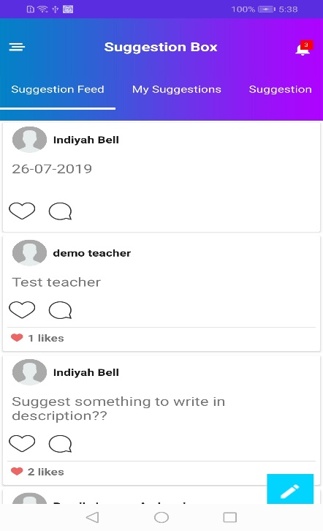 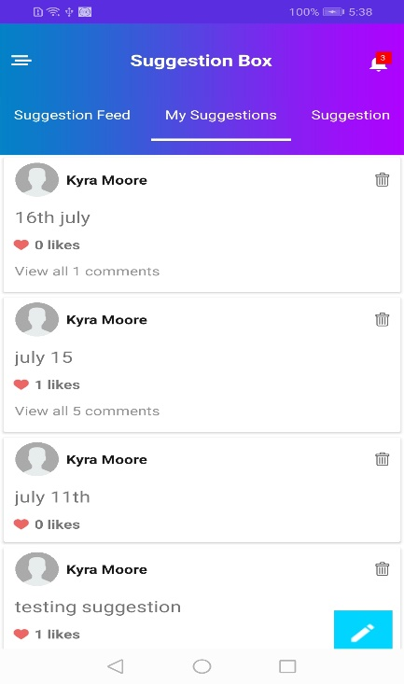 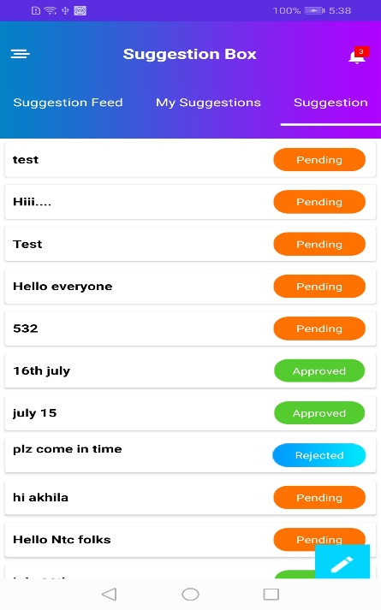

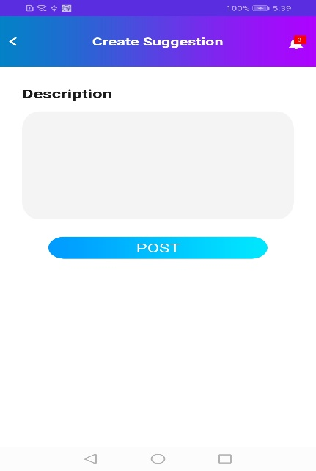

### Digital Binder:

The Digital Binder page displays all the assignments of students. Students can add a new assignment from this page. Also can edit the assignment.

#### Adding a New Assignment:

Click the **Add** button.

You will be redirected to the New Assignment page. On this page, specify the assignment name and description, attach media such as pictures or videos and click the **Submit** button.

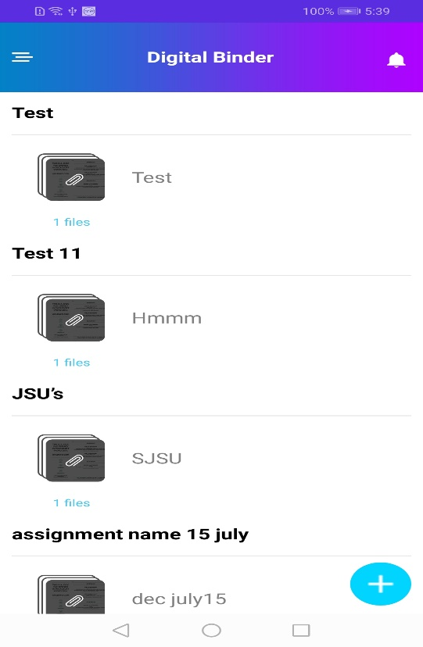 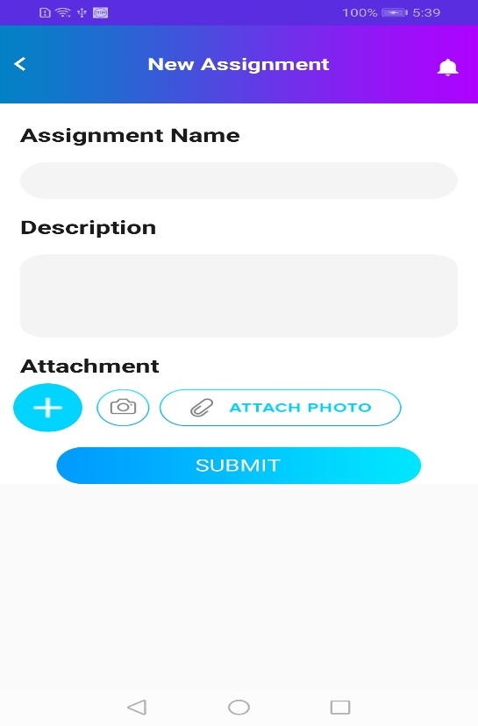

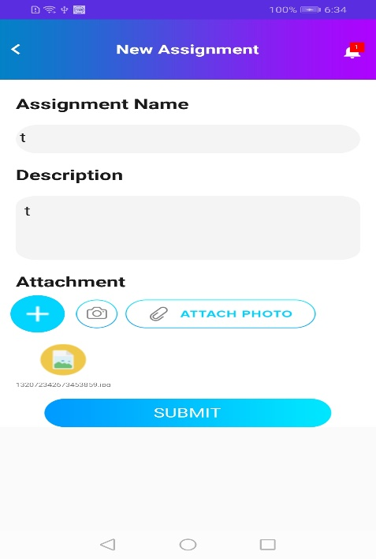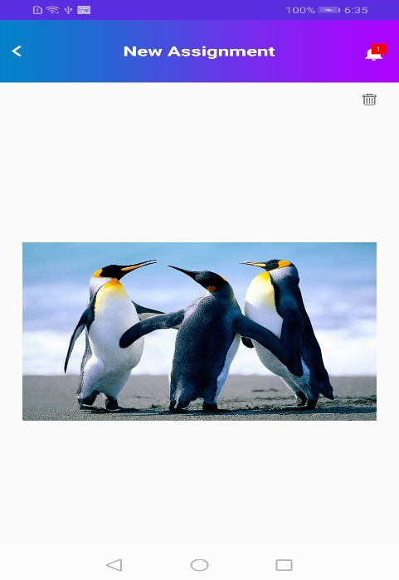

### Help:

The Help page contains the information about the different sections of the application and the instructions to help you use the application easily.

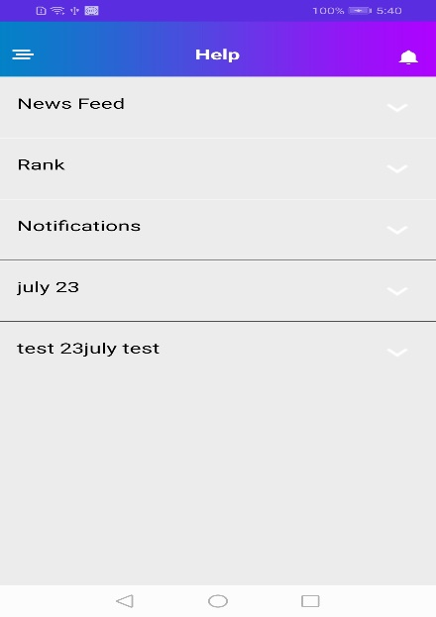

## Teacher Login

### Home:

When you log in as a Teacher, you can view the News Feeds posted by Students, Teachers or Admin users. You can post your post which can be a piece of Text, Pictures, Videos etc. You can also like posts, comment on posts, edit your post, delete your post etc.

**Note:** There are some rules and regulations for teachers while posting a new post or commenting on an existing post. They cannot post any objectionable text, pictures or videos . Their posts need to be approved by an approver before being published. The approvers can approve or reject posts.

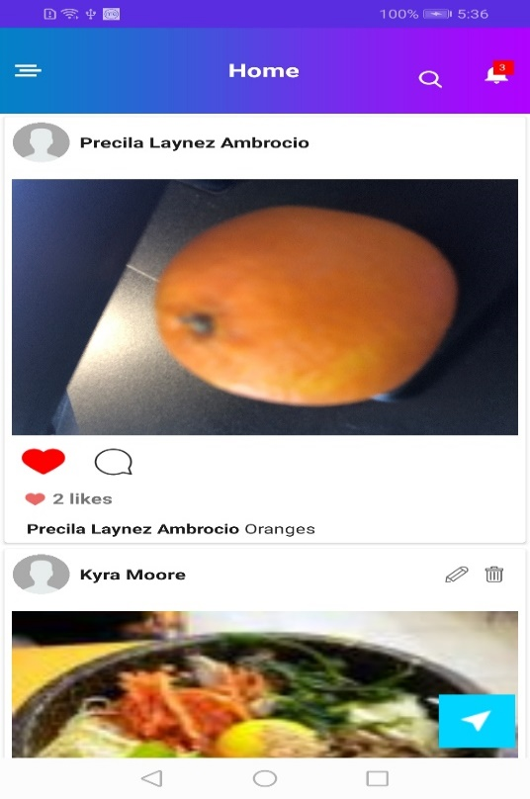 

 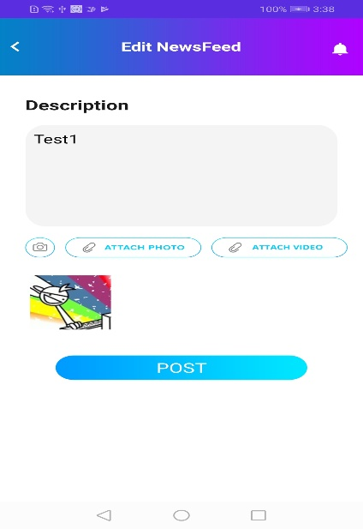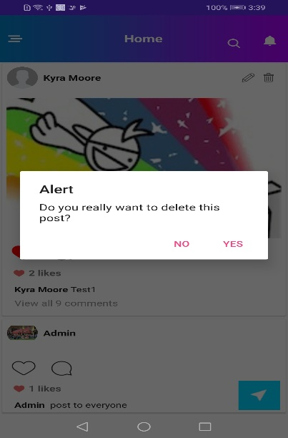

#### Search:

Teachers can search for information on the app based on certain key words. There is a **Search** text box available at the top of the Home page. They can type in their keyword and the search result will be displayed below the **Search** text box based on the t keyword typed in.



### Notifications:

The Notification page displays all the notifications such as the likes or comments made on your post, notifications when the hall pass is approved, etc. This page will display all the updates related to Teachers. You can click on any notification to access the details of that particular notification.

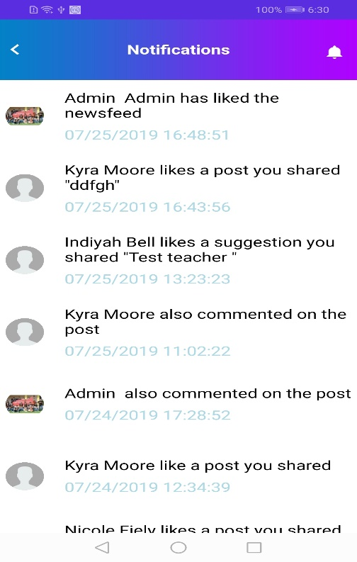 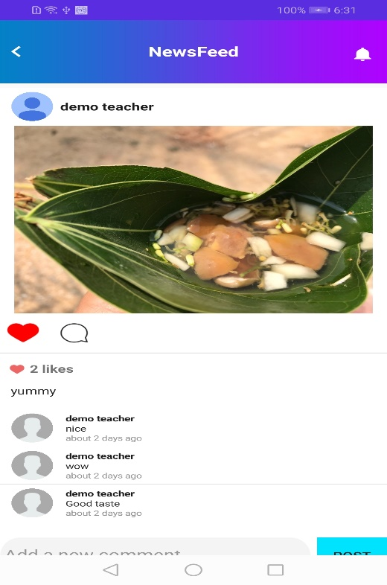

### Menu:

There is a **Menu** icon displayed at the top left corner of the Home page. You can click on this icon to view the list of menu options available from which you can select the menu you want and navigate to that particular page.

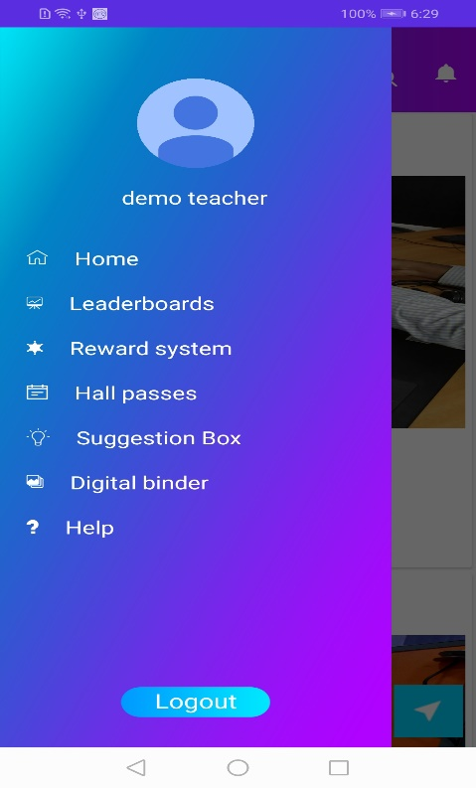

### LeaderBoards:

The Leaderboards page displays the details of the Students. Details such as Rank, Points, Levels etc. are displayed. You can filter these details by clicking the **My School** toggle button.

**Note:** If the **My School** toggle button is enabled after logging in, then you can view only the details of the students belongs to your own school and if the toggle button is disabled, you can view the details of all the students of all the schools.

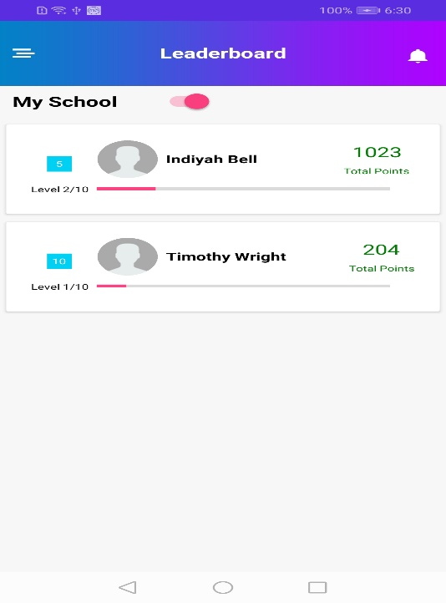 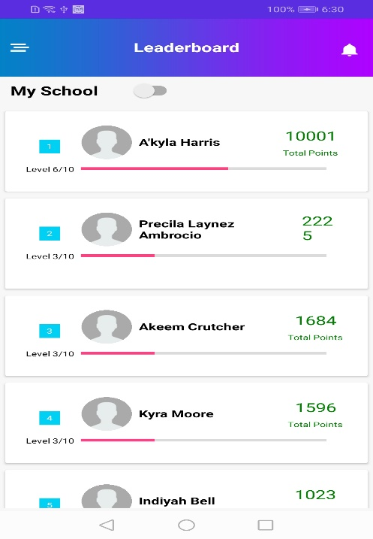

### Rewards System:

On this page, Teachers can assign give rewards points to their students.

**Assigning Rewards:**

* Select the student from the Select a Student drop-down list
* Mention the number of points and the reason for assigning the rewards in the respective text boxes
* Click the **Submit** button.

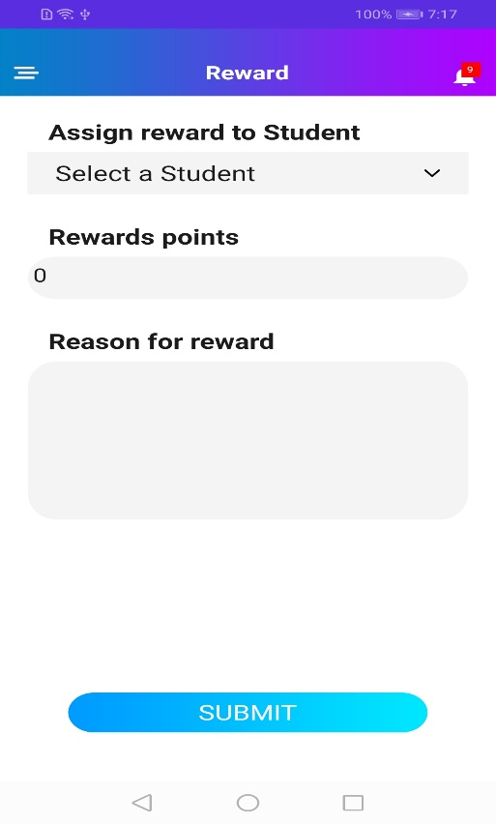

### Hall Passes:

The Hall Passes page contains three tabs. The first tab is the **Hall Pass Request** tab which displays all the hall pass requests along with information such as description, destination, valid from, expire on etc. You can approve or reject a hall pass by clicking on the **Approve** and **Reject** buttons.

The second tab is the **Publish Hall Pass** tab**.** You canpublish new hall passes for students. You need to specify information such as student name, reason, destination, start date time, and end date time.

**Note:** You cannot choose a past date range for the hall passes. You need to always choose a future date range

The third tab is the **All Passes** tabwhich displays all the hall passes that have a status associated with them.

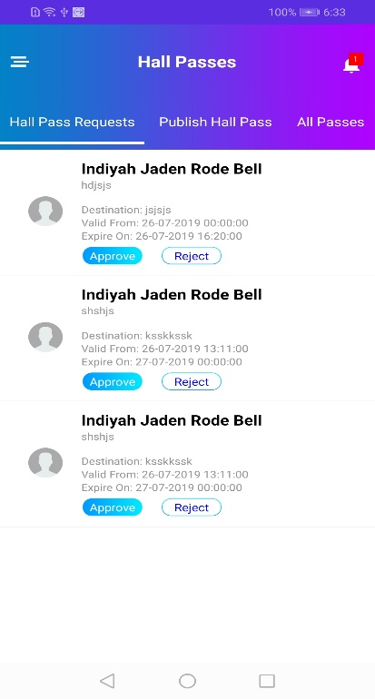 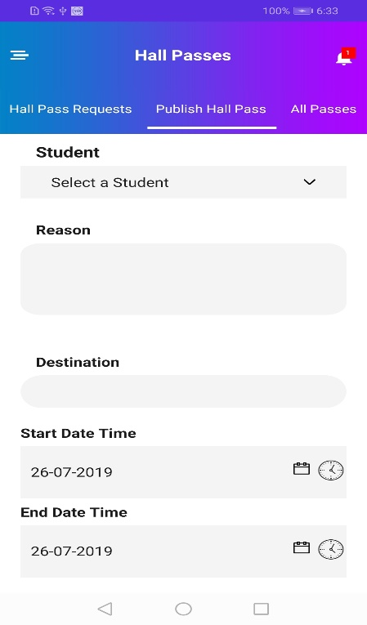 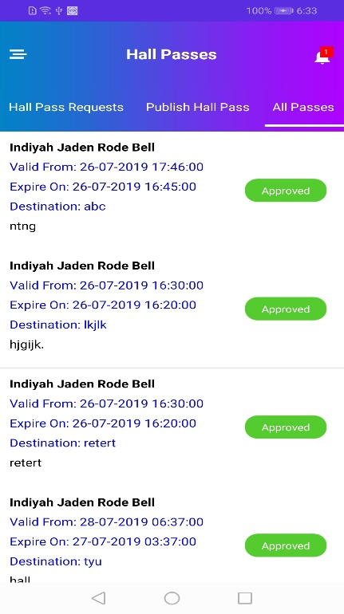

### Suggestion Box:

The Suggestion Box page for teachers displays the suggestions posted by the students logged in to the app. You can like or comment on those suggestions.

#### Adding a New Suggestion:

* You can add a new suggestion by clicking the **Add** button.
* You will be redirected to the Create Suggestion page where you can describe your suggestion and post it by clicking the **Post** button.

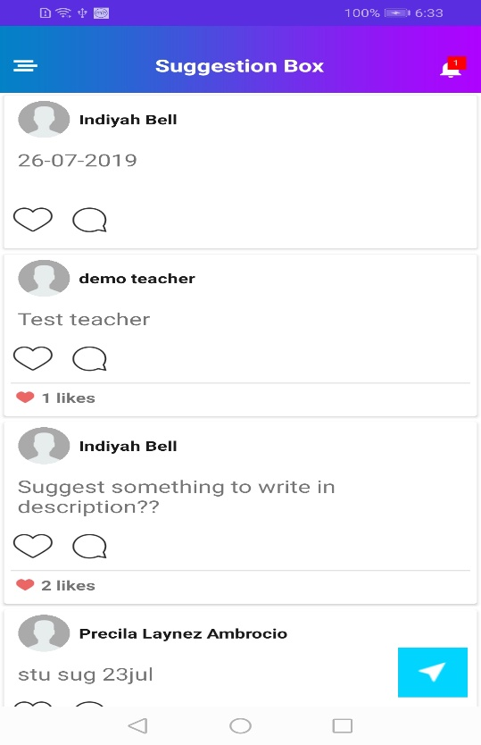

### Digital Binder:

The Digital Binder page displays all the assignments of those students assigned to you. You can add a new assignment from this page. Also can edit the assignment.

#### Adding a New Assignment:

* Click the **Add** button.
* You will be redirected to the New Assignment page. On this page, specify the assignment name and description, attach media such as pictures or videos and click the **Submit** button.

You can also edit the students’ assignments and view their attachments as shown below.

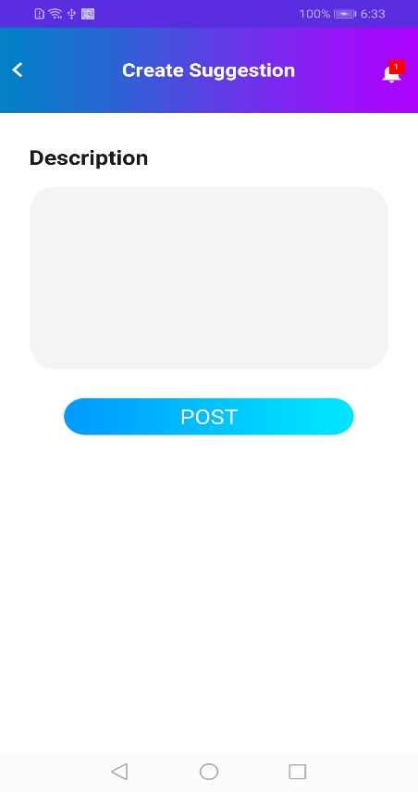 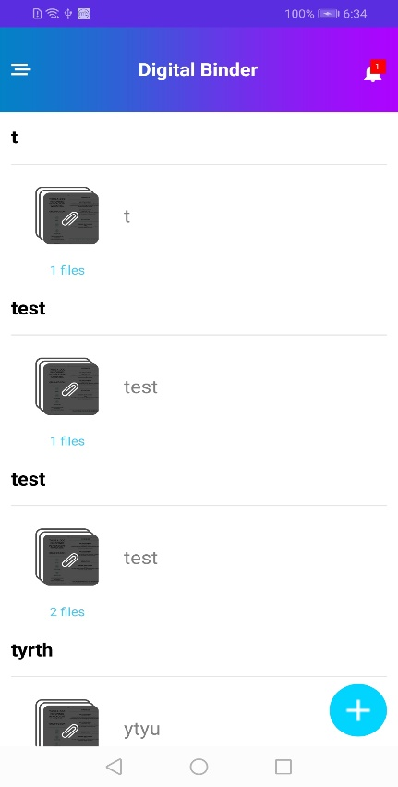 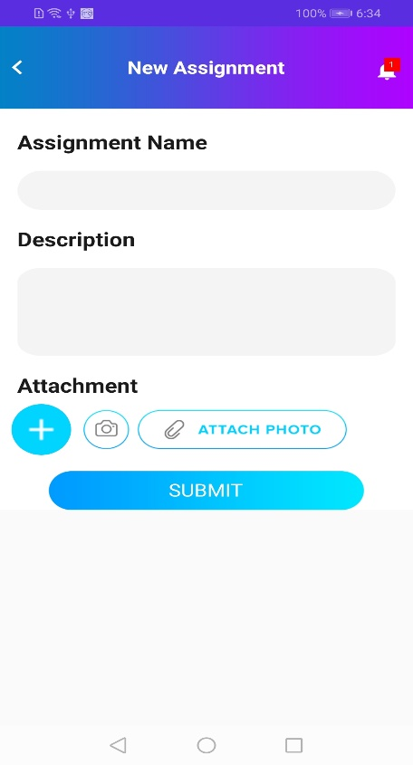



### Help:

The Help page contains the information about the different sections of the application and the instructions to help you use the application easily. 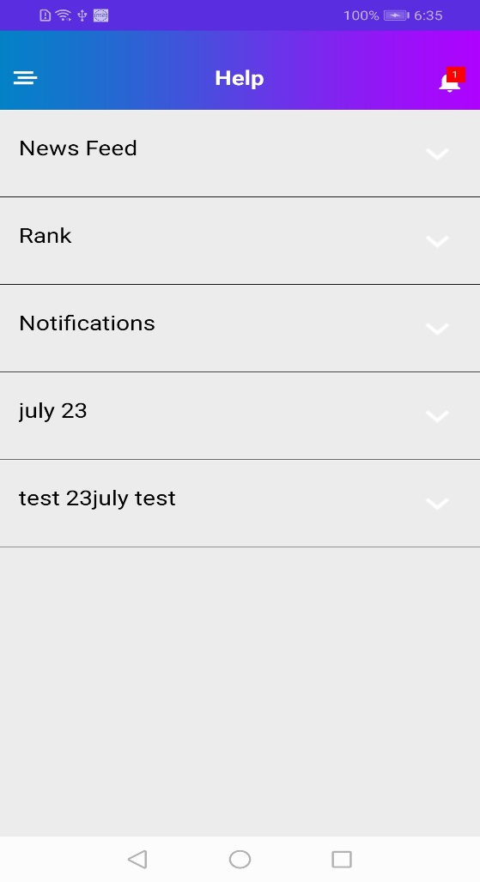

# Student & Teacher Website

## Logging in

To log in to the Cincinnati Public Schools website as a Student or Teacher, perform the following steps:

* Click the **Student** or **Teacher** button from the log in screen.

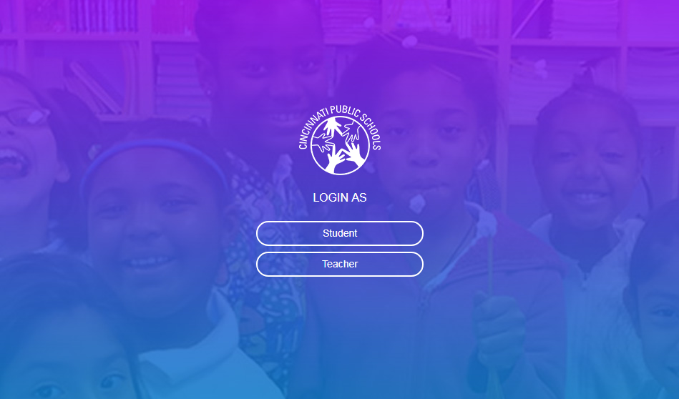

* After selecting the appropriate button, you will be redirected to the Sign in with Google screen.
* Click the **Sign in with Google** button. You will be redirected to the Choose an Account screen.

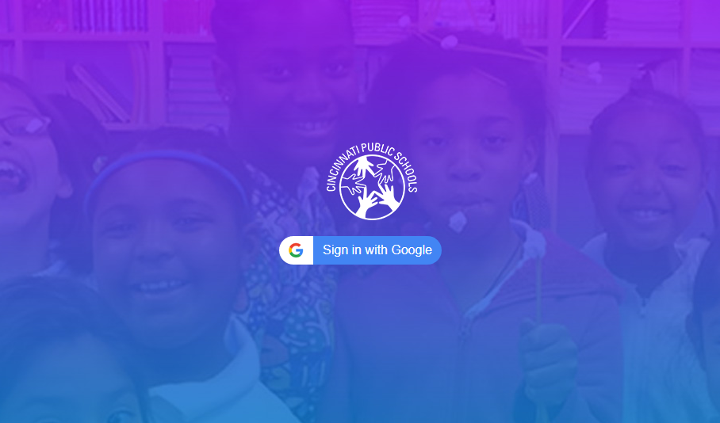

* On this screen, select an existing account or create a new account. Provide the password when asked for.

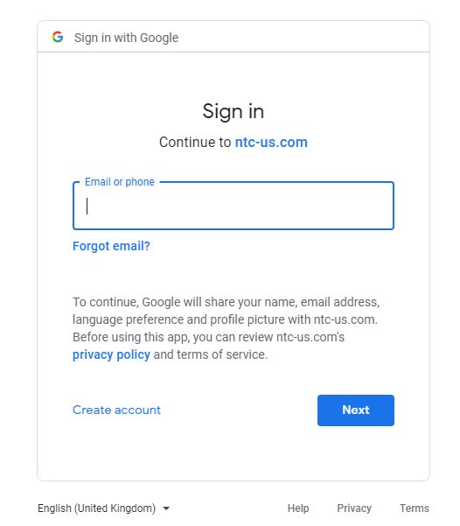

* After entering a valid password, you will be redirected to the Dashboard screen of the CPS website.

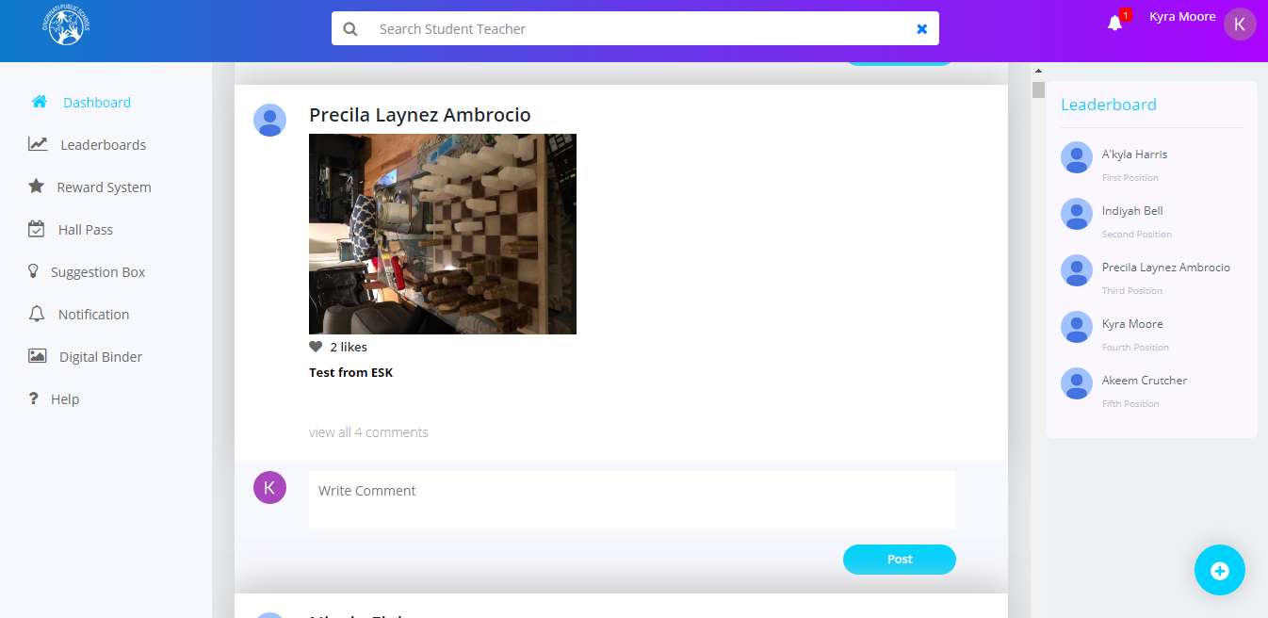

## Student Login

### Dashboard:

When you log in as a Student, you can view the Newsfeeds (posts) posted by Students, Teachers or Admin users on the Dashboard screen.

#### Search:

Students can search for information on the website based on certain key words. There is a **Search** text box available at the top of the Dashboard screen. They can type in their keyword and the search result will be displayed below the **Search** text box based on the keyword typed in.

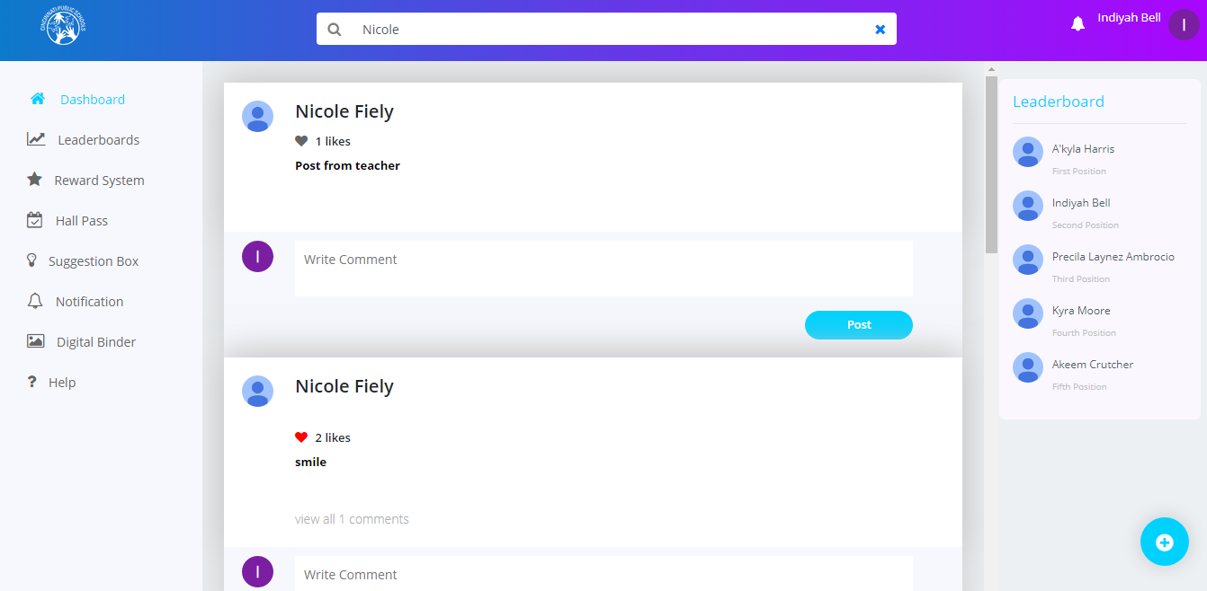

#### Adding a Newsfeed

On this screen, students can post a piece of Text, Pictures, Videos etc. They can also like posts, comment on posts etc.

To add a news feed:

* Click the + icon . The Create News window is displayed.

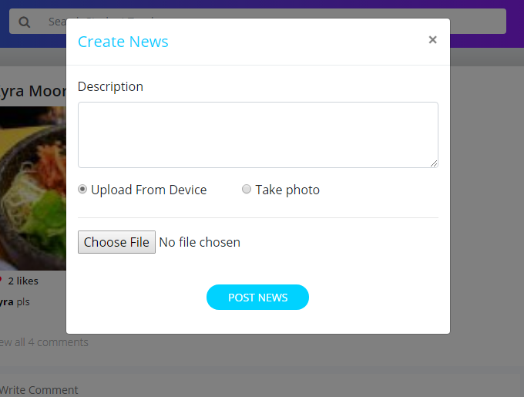

* In this screen, you can upload a file from the device or you can click a picture using the webcam.
* After filling in the information click on the **Post News** button to post the news feed.

**Note:** There are some rules and regulations for a student while posting a new newsfeed (post) or when commenting on an existing newsfeed. A student cannot post any objectionable pictures, videos etc. All the posts made by Students need to be approved by an approver before being posted on the website. The approver can approve or reject Students’ newsfeeds.

Editing or Deleting a News Feed

Students can edit or delete only their newsfeeds posted on their individual dashboards by clicking the 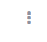icon.

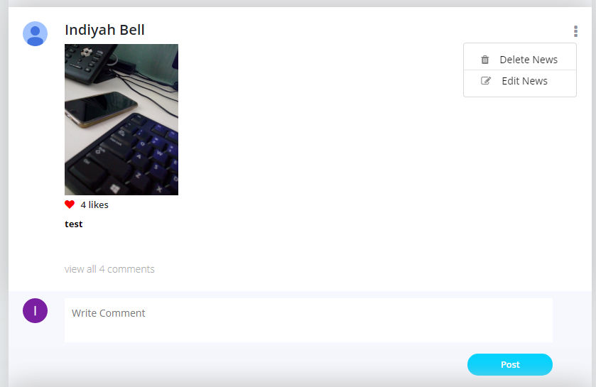

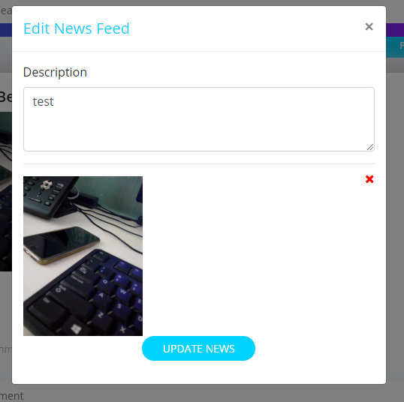

#### To edit a newsfeed:

* Click on the icon and click the **Edit News** button. The Edit News Feed window is displayed.
* Edit the description and upload a different image or
* Click the **Update News** button to save your changes

**Note:** You need to delete the existing video or image to upload a new one in its place.

To delete a newsfeed:

* Click on the icon and click the **Delete News** button.

### Commenting on a Newsfeed

Students can comment on newsfeeds in displayed in the Dashboard screen.

To comment on a newsfeed:

* Select the newsfeed you wish to comment on from the Dashboard screen.
* Type in your comment in the **Write** text box.
* Click the **Post** button.

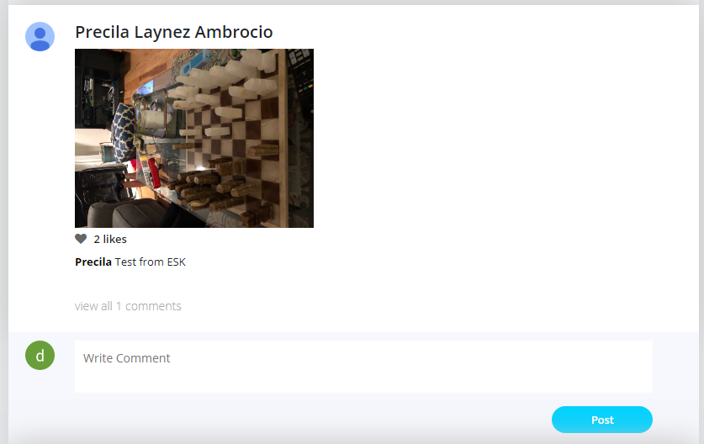

**Note:**

* All the comments made by Students need Admin approval.
* You can view all the comments for that news feed by clicking the view all comments link.

### Notifications

On this screen, Students can view all the notifications sent to them.

To view your notifications:

* Click the Notifications bell icon to view all the top notifications.
* Click on a notification to view its details.

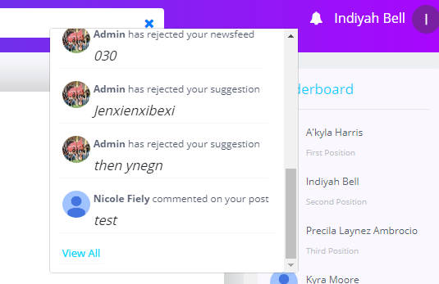

**Note:** To view all the notifications such as the likes or comments made on your posts, notifications sent when the hall pass is approved, etc. you can click the View All link at the bottom of the notifications list or click the Notification link in the Dashboard screen.

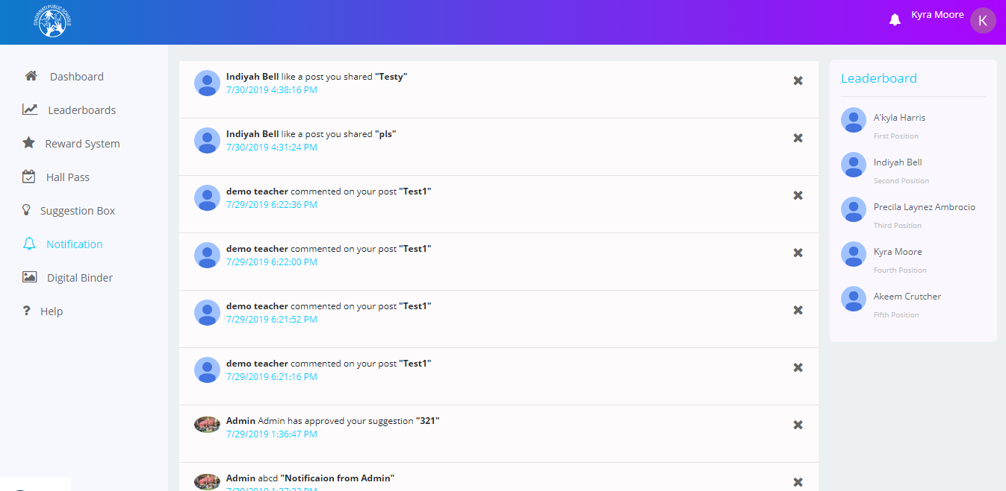

### Leaderboards:

The Leaderboards screen displays the details of the logged in Student. Details such as Rank, Points, Levels etc. are displayed. This screen also displays the number of points required to reach the next levels. You can filter these details by selecting or unselecting the **My School** checkbox.

**Note:** If the **My School** checkbox is selected after logging in, then you can view only the details of the students who belong to your own school and if the checkbox is unselected, you can view the details of all the students of all the schools.

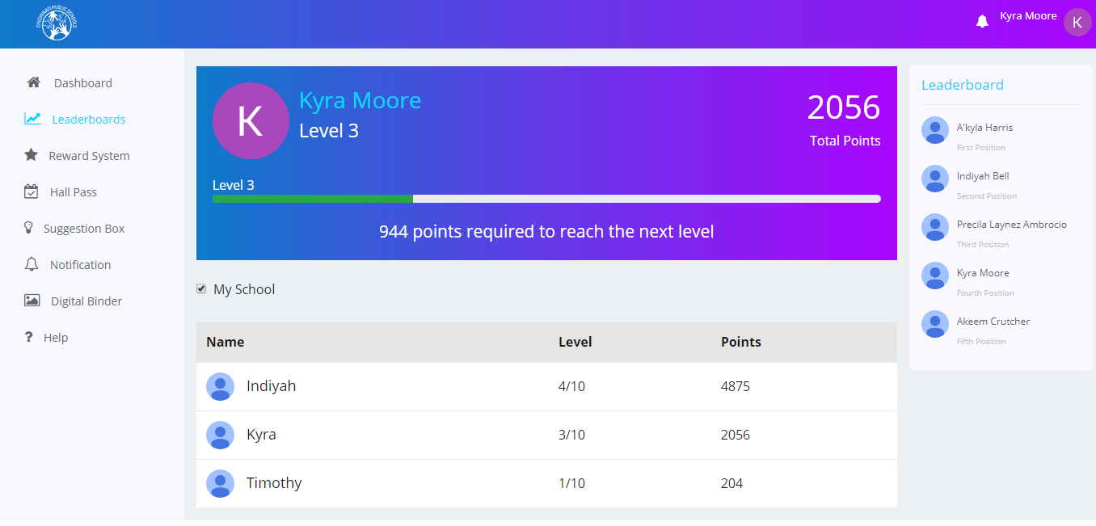

### Rewards System: (Future Implementation)

The Rewards System screen displays the details of the logged in student such as Total Points, Rank etc. This screen contains two buttons **Redeem my Points** and **How to Earn Points**. You can click the **Redeem my Points** button to redeemyour reward points. You can click the **How to Earn Points** button to get help on how to earn points.

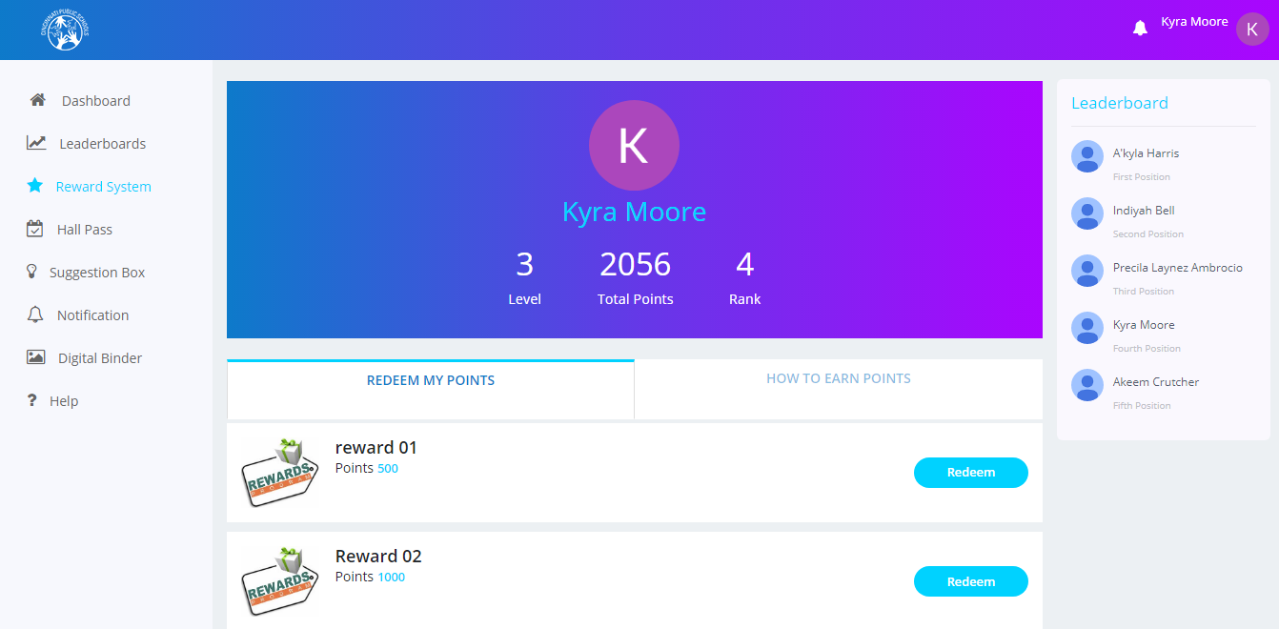

### Hall Passes:

The Hall Passes screen consists of two tabs. They are, **Request a hall pass** tab which displays all the hall pass requests along with the status of the respective hall pass and the **My Passes** tab which displays all the hall passes requested by the logged in user along with details such as Name, Valid From, Expires On, Description, Destination, Approved by etc.

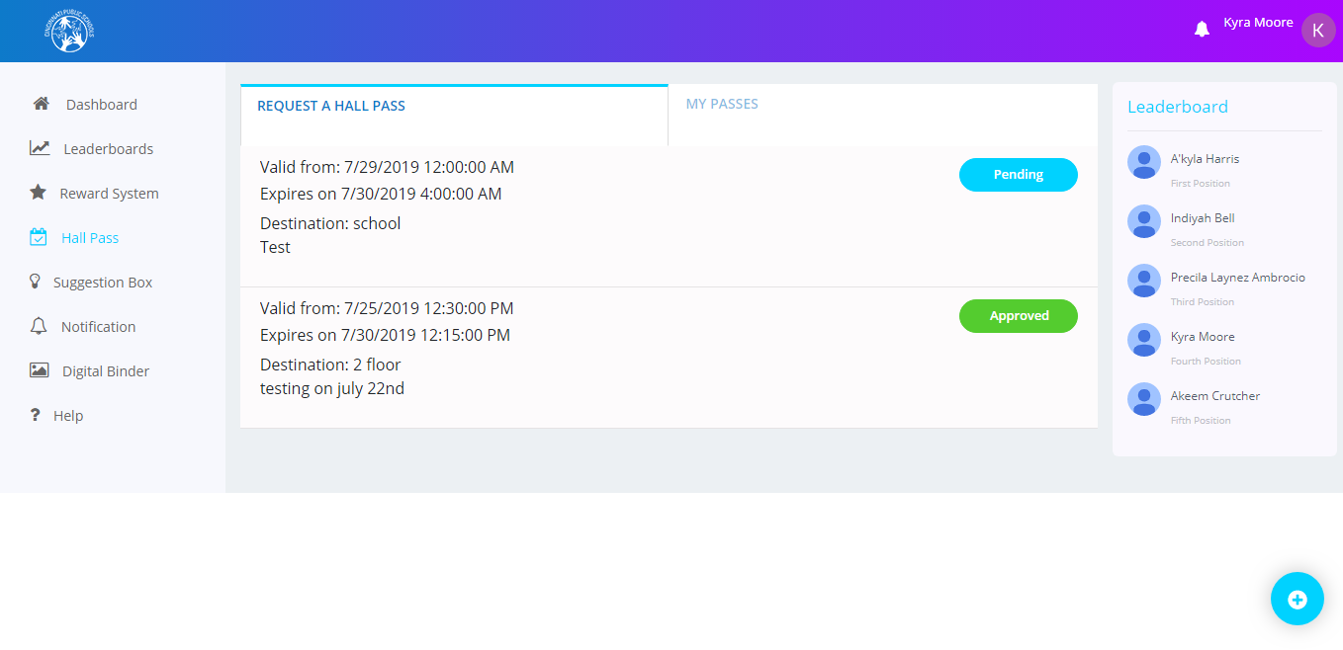

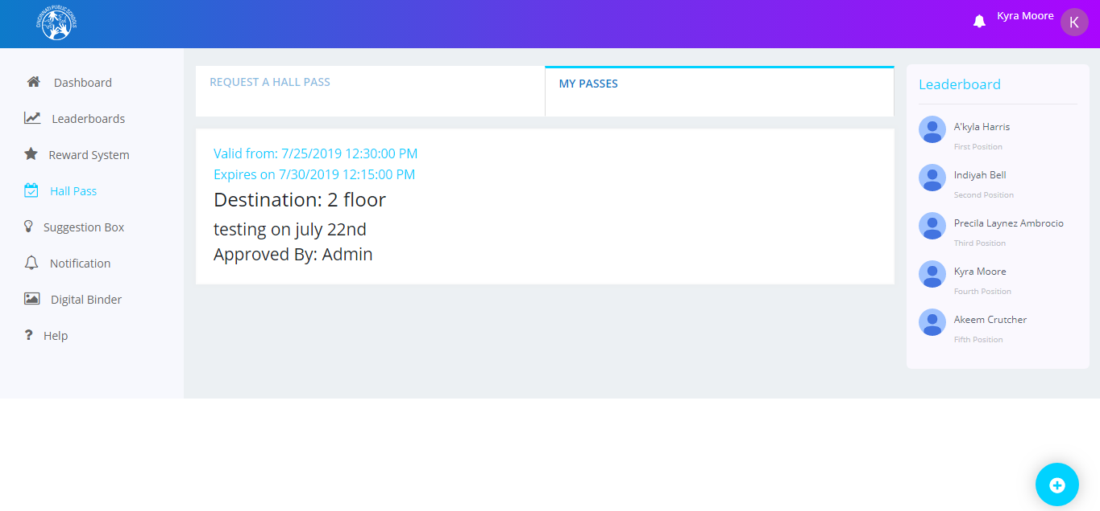

#### Adding a new Hall Pass

To add a new hall pass:

* Click the + icon displayed at the bottom right corner of the Request a hall pass screen.
* The New Hall pass window is displayed.
* On this screen, fill in information such as Requesting teacher’s name, Reason, Destination, Start Date Time, End Date Time etc.

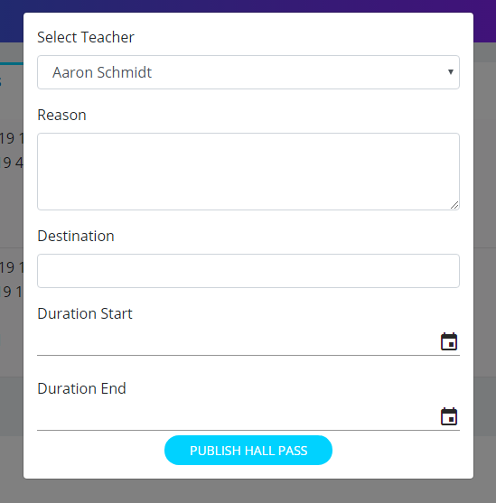

* Click the **Publish Hall Pass** button at the bottom of the screen. After clicking this button, a hall pass request will be generated, and the selected teacher and Administrator will get a notification asking for the approval or rejection of that hall pass.

### Suggestion Box (Future Implementation):

The Suggestion Box screen for students has three tabs; **Suggestion Feed**, **My Suggestions**, and **Suggestion**. The **Suggestion Feed** tab displays the suggestions of all the students logged in to the app. You can like or comment on those suggestions.

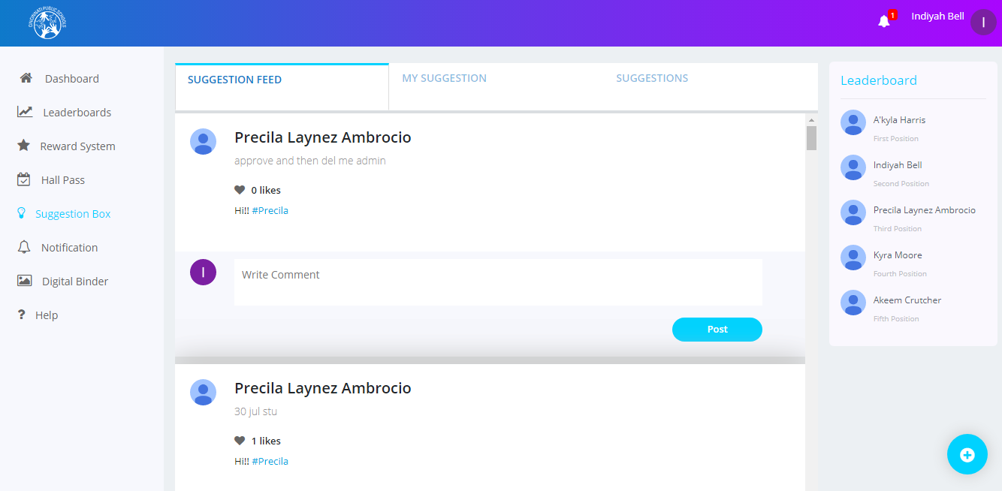

#### Adding a New Suggestion

To add a new suggestion:

* You can add a new suggestion by clicking the + icon displayed at the bottom of the **Suggestion Feed** tab.
* The Create Suggestion window is displayed.

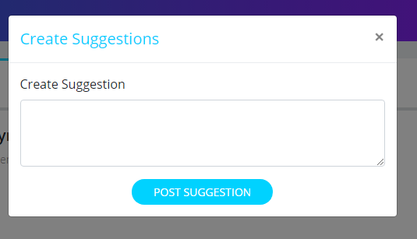

* Describe your suggestion in the Create Suggestion text box and click the **Post** **Suggestion** button to post your suggestion.

The **My Suggestions** tab displays the suggestions posted by you -the logged in user. It also displays the likes and comments on the respective suggestion selected by you.

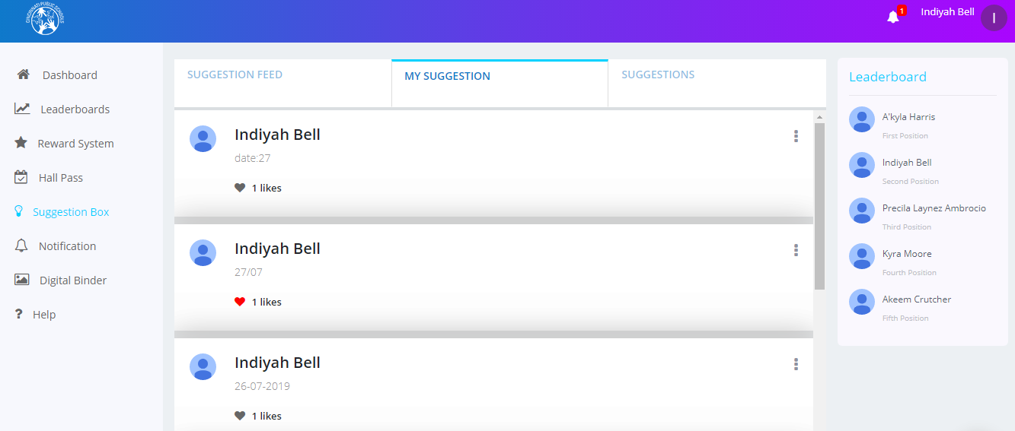

The **Suggestion** tab contains your suggestions along with the status of the suggestions such as Approved, Pending or Rejected.

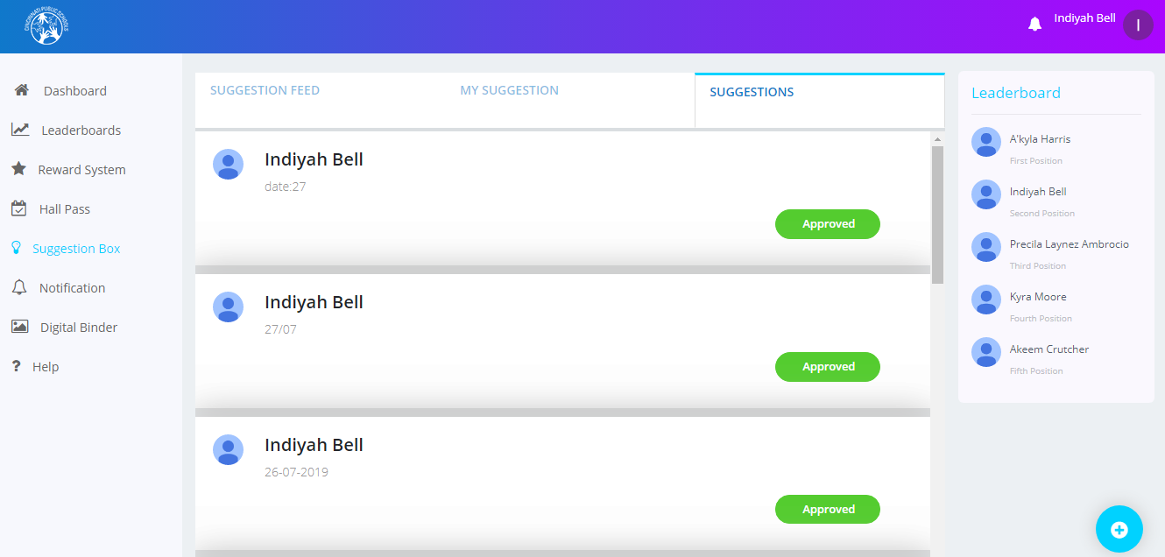

### Digital Binder:

The Digital Binder screen displays all the assignments of students. Students can add a new assignment from this screen.

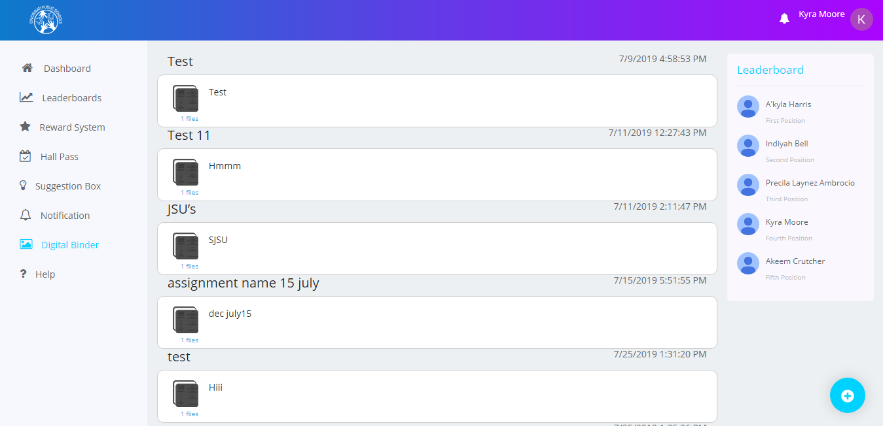

#### Adding a New Assignment

To add a new assignment:

* Click the + icon displayed at the bottom of the Digital Binder screen. The New Assignment window is displayed.

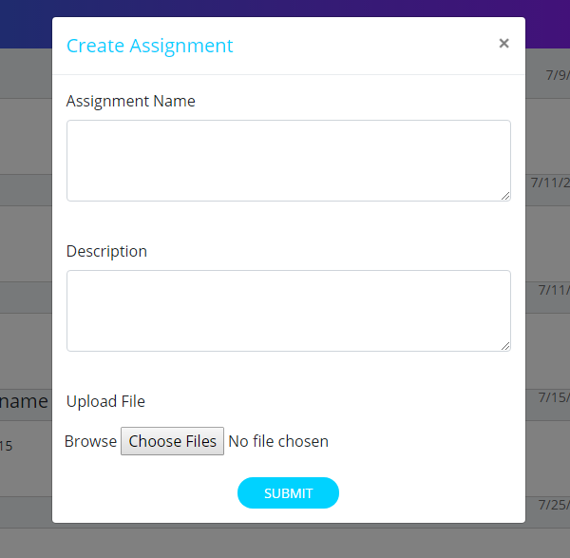

* Specify the assignment name and description, attach media such as pictures or videos and click the **Submit** button.

You can also edit the assignments and view their attachments.

To edit assignments:

* Click the file icon on the Digital Binder screen. The Edit Assignment window is displayed.

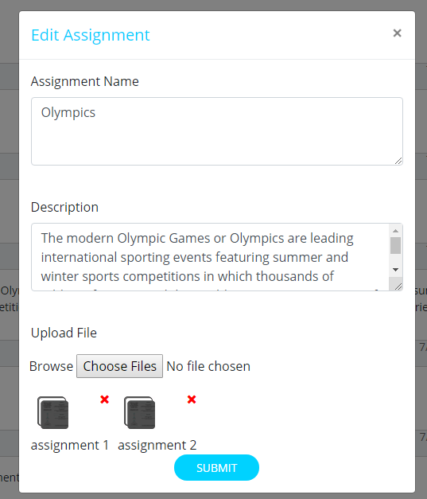

You can edit the details of the assignment and view or remove the assignment’s attachment.

To view the attachment:

* click the file icon displayed below the Description text box. The image is displayed in a new tab.
* Click the x delete symbol to delete the attachment.

### Help:

The Help screen contains the information about the different sections of the application and the instructions to help you use the application easily.

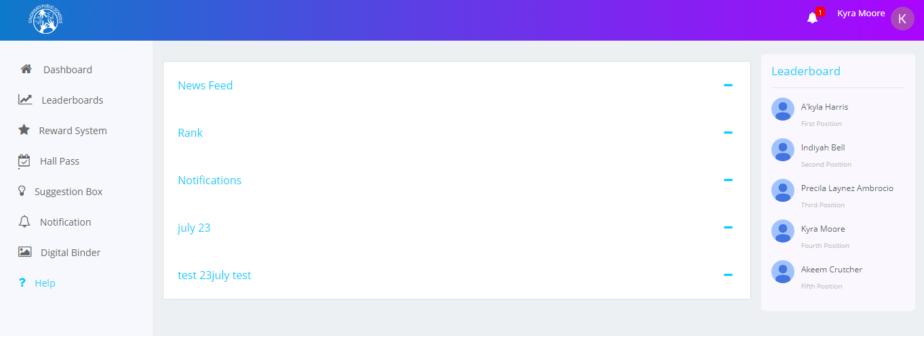

## Teacher Login

### Dashboard:

When you log in as a Teacher, you can view the News Feeds posted by Students, Teachers or Admin users. You can post your post which can be a piece of Text, Pictures, Videos etc. You can also like posts, comment on posts etc.

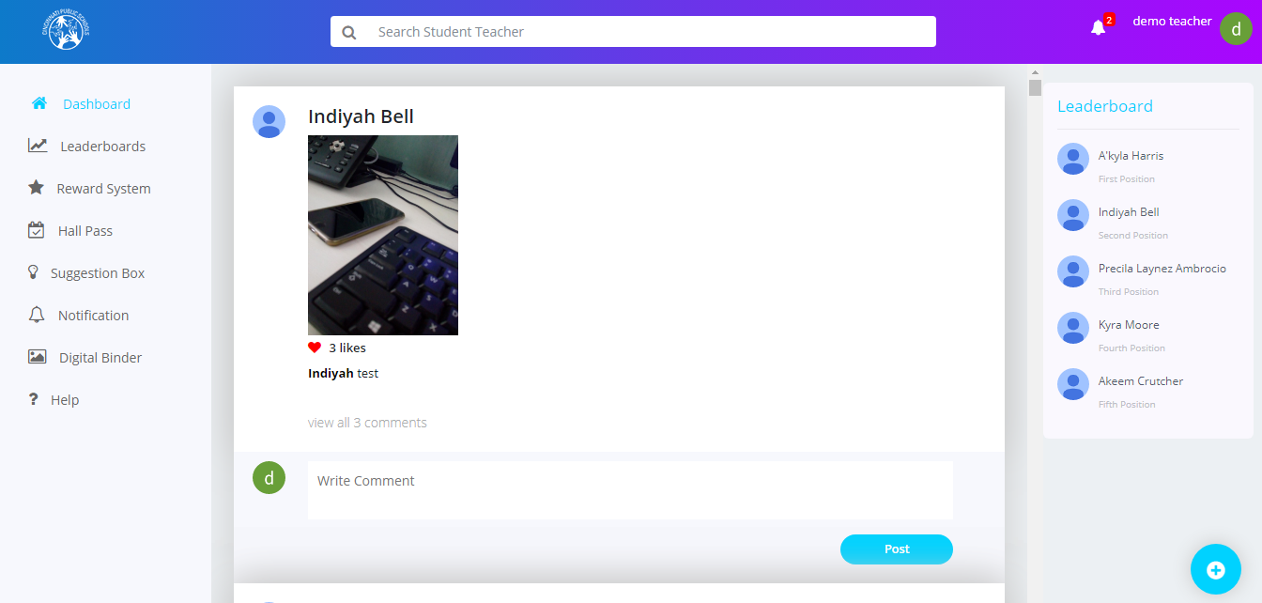

### Search:

Teachers can search for information on the website based on certain key words. There is a **Search** text box available at the top of the Dashboard screen. They can type in their keyword and the search result will be displayed below the **Search** text box based on the keyword typed in.

### 

#### Adding News feed

On this screen, teachers can post a piece of Text, Pictures, Videos etc. User can also like posts, comment on posts etc.

To add newsfeed:

* Click the + icon at the bottom of the Dashboard screen. The Create News window is displayed.

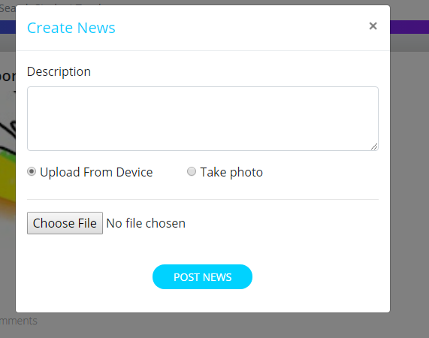

* In this screen, you can upload a file from the device or you can click a picture using the webcam.
* After filling in the information click on the **Post News** button to post the News feed.

**Note:** There are some rules and regulations for a teacher while posting a new newsfeed or when commenting on an existing one. A teacher cannot post any objectionable pictures, videos etc. All the newsfeeds posted by teachers need to be approved by an approver before being posted on the website. The approver can approve or reject teachers’ newsfeeds.

#### Editing or Deleting a Newsfeed

Teachers can edit or delete only their newsfeeds posted on their individual dashboards by clicking the icon.

To edit a newsfeed:

* Click on the icon and click the **Edit News** button. The Edit News Feed window is displayed.
* Edit the description and upload a different image or
* Click the **Update News** button to save your changes

**Note:** You need to delete the existing video or image to upload a new one in its place.

To delete a newsfeed:

* Click on the icon and click the **Delete News** button.

### Notifications:

The Notifications screen displays all the updates related to Teachers such as the likes or comments made on the newsfeeds, notifications when the hall pass is approved, etc. You can click on any notification to access the details of that notification.

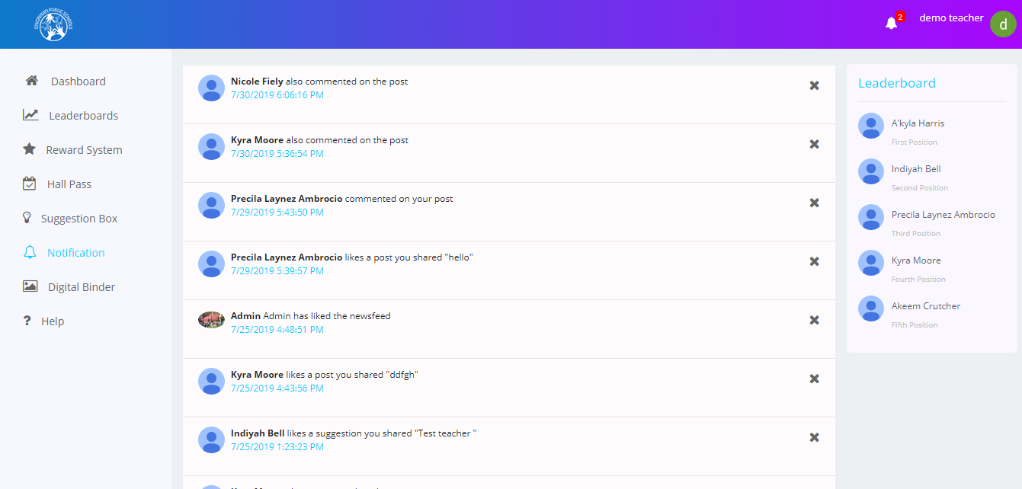

### Leaderboards:

The Leaderboards screen displays the details of the Students. Details such as Rank, Points, Levels etc. are displayed. You can filter these details by selecting or unselecting the **My School** checkbox.

**Note:** If you select the **My School** checkbox, you can view the details of only those students who belong to your school.

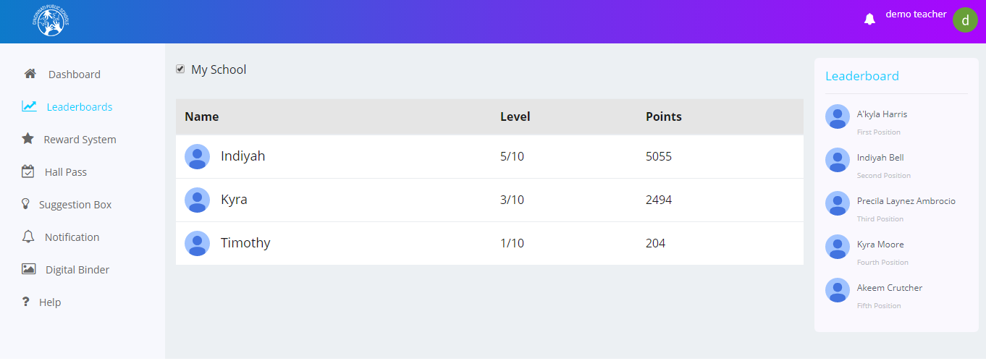If you unselect the checkbox, you can view the details of all the students of all the schools.

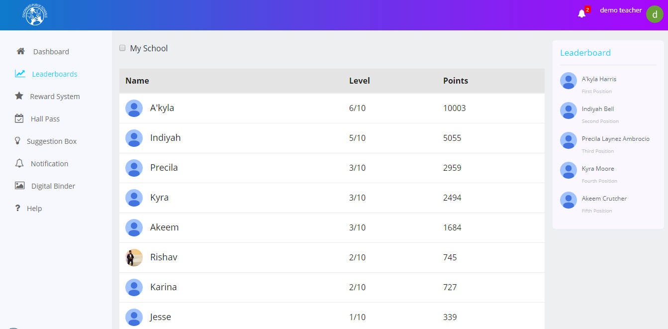

### Rewards System:

On this screen, Teachers can assign reward points to their students.

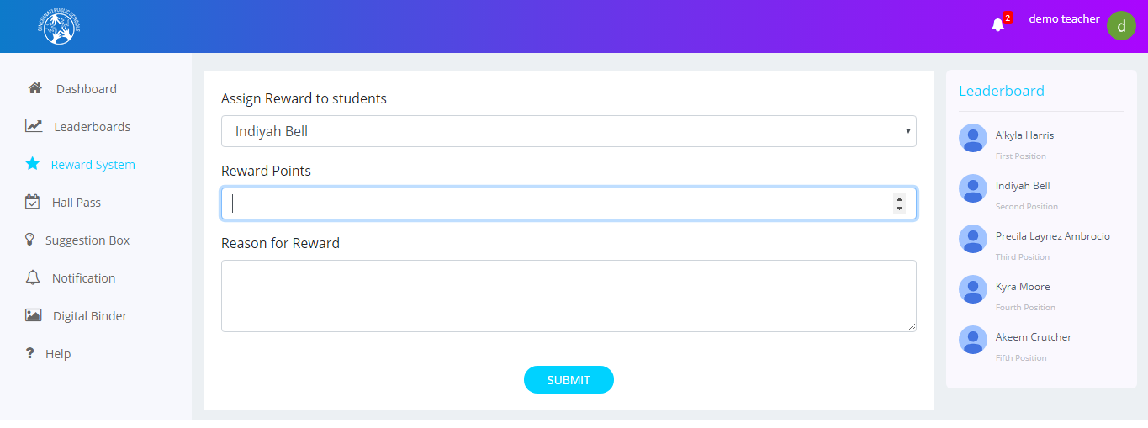

#### Assigning Rewards

To assign rewards to a student:

* Select the student from the **Select a Student** drop-down list
* Mention the number of points and the reason for assigning the rewards in the respective text boxes
* Click the **Submit** button.

### Hall Passes:

The Hall Passes screen contains three tabs.

The first tab is the **Hall Pass Request** tab which displays all the hall pass requests along with information such as description, destination, valid from, expire on etc. You can approve or reject a hall pass by clicking on the **Approve** and **Reject** buttons.

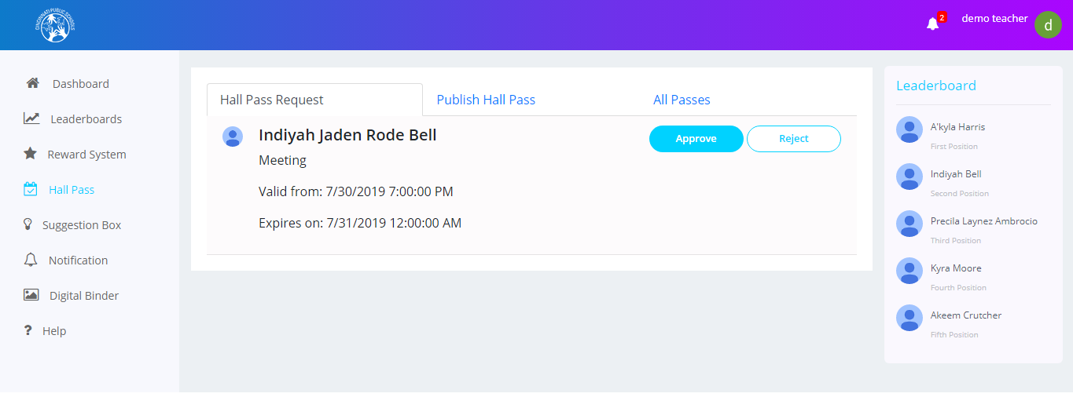

The second tab is the **Publish Hall Pass** tab, whereyou canpublish new hall passes for students. You need to specify information such as student name, reason, destination, start date time, and end date time and click the **Submit** button

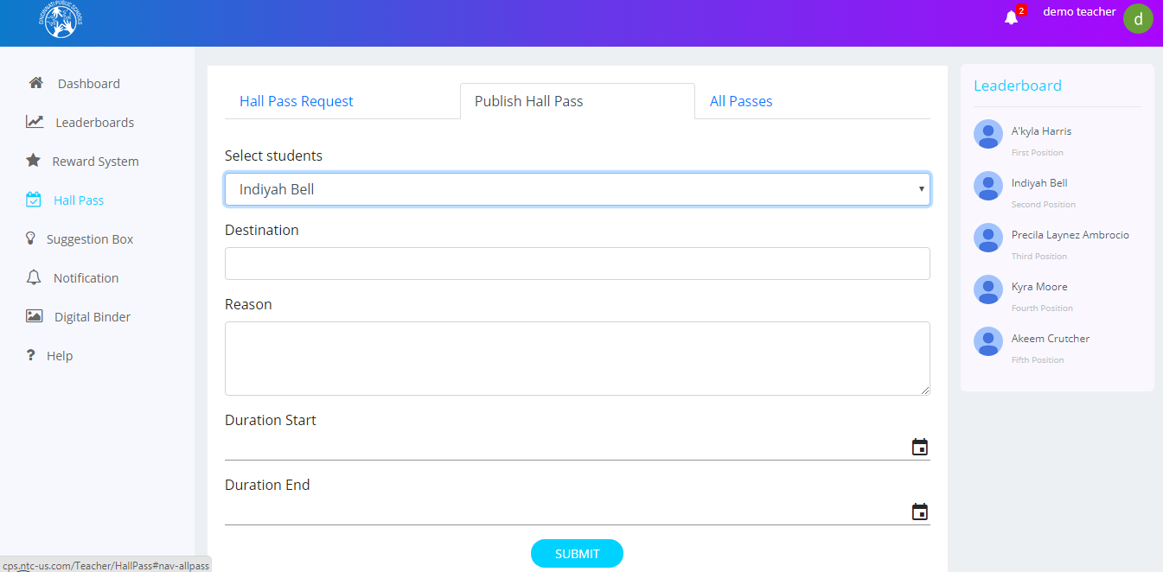

**Note:** You cannot choose a past date range for the hall passes. You need to always choose a future date range.

The third tab is the **All Passes** tabwhich displays all the hall passes that have a status associated with them.

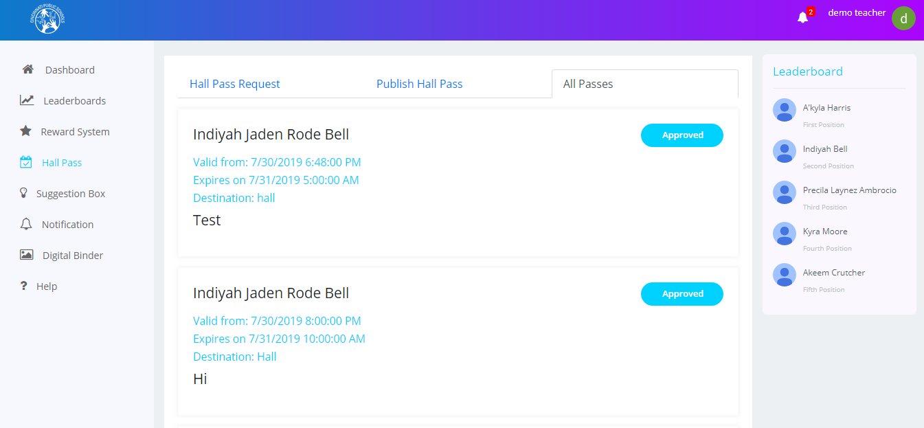

### Suggestion Box:

The Suggestion Box screen for teachers displays the suggestions posted by the students who are logged in to the website. You can like or comment on those suggestions.

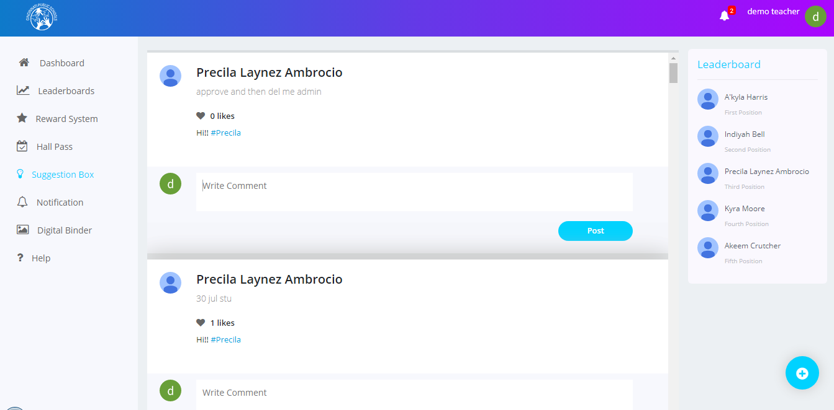

#### Adding a New Suggestion

To add a new suggestion:

* Click the + icon in the Suggestion Box screen.

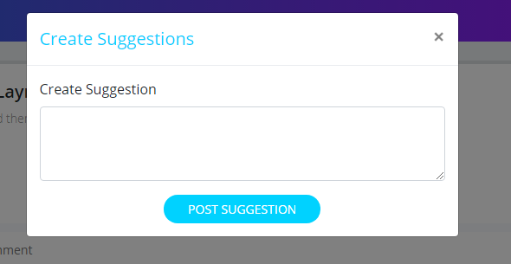

* The Create Suggestion window is displayed. In this window, describe your suggestion and post it by clicking the **Post** **Suggestion** button.

### Digital Binder:

The Digital Binder screen displays all the assignments of those students assigned to you. You can add a new assignment from this screen.

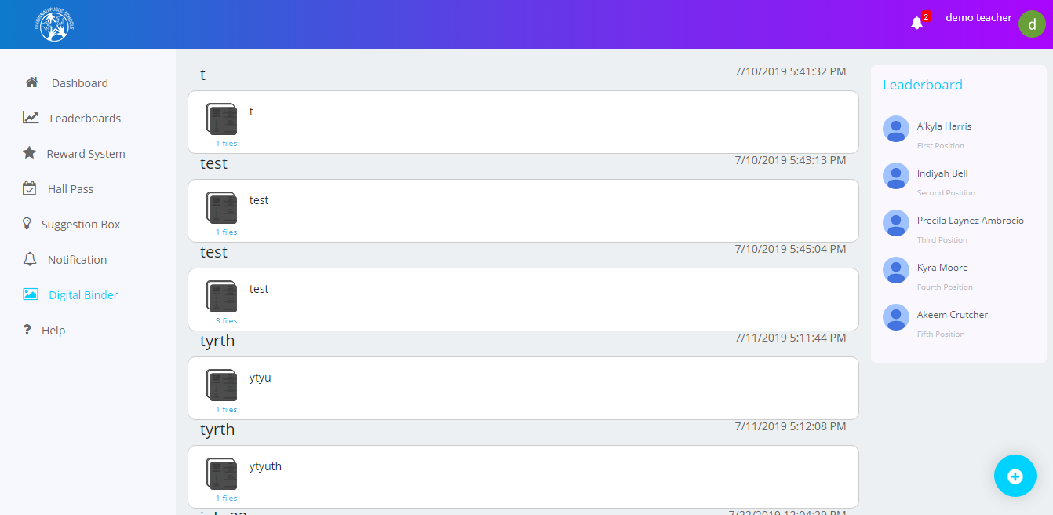

#### Adding a New Assignment:

To add a new assignment:

* Click the **Add** button from the Digital Binder screen.
* The New Assignment window is displayed. in this window, specify the assignment name and description, attach media such as pictures or videos and click the **Submit** button.



You can also edit the assignments and view their attachments.

To do so:

* Click the file icon on the Digital Binder screen. The Edit Assignment window is displayed.



You can edit the details of the assignment and view or remove the assignment’s attachment.

* To view the attachment, click the file icon displayed below the Description text box. The image is displayed in a new tab.
* Click the x delete symbol to delete the attachment.

### Help:

The Help screen contains the information about the different sections of the application and the instructions to help you use the application easily.

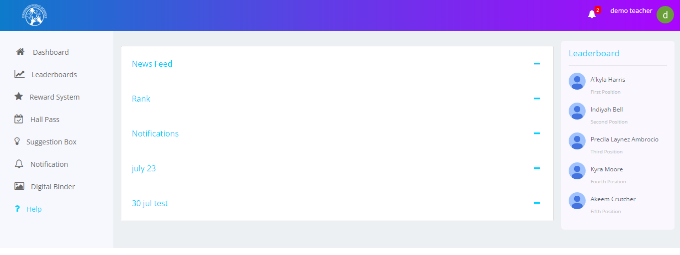

## Logging Out:

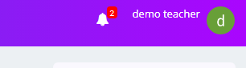

* Click on the user icon to view the logout screen.

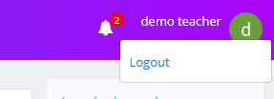

* Click on Logout to exit from the website.

# Admin

## Logging in:

To log in to the Cincinnati Public Schools website as an Administrator, perform the following steps:

* Enter valid username and password in the respective text boxes and click the **Login** button.
* You will be redirected to the Admin Dashboard screen.

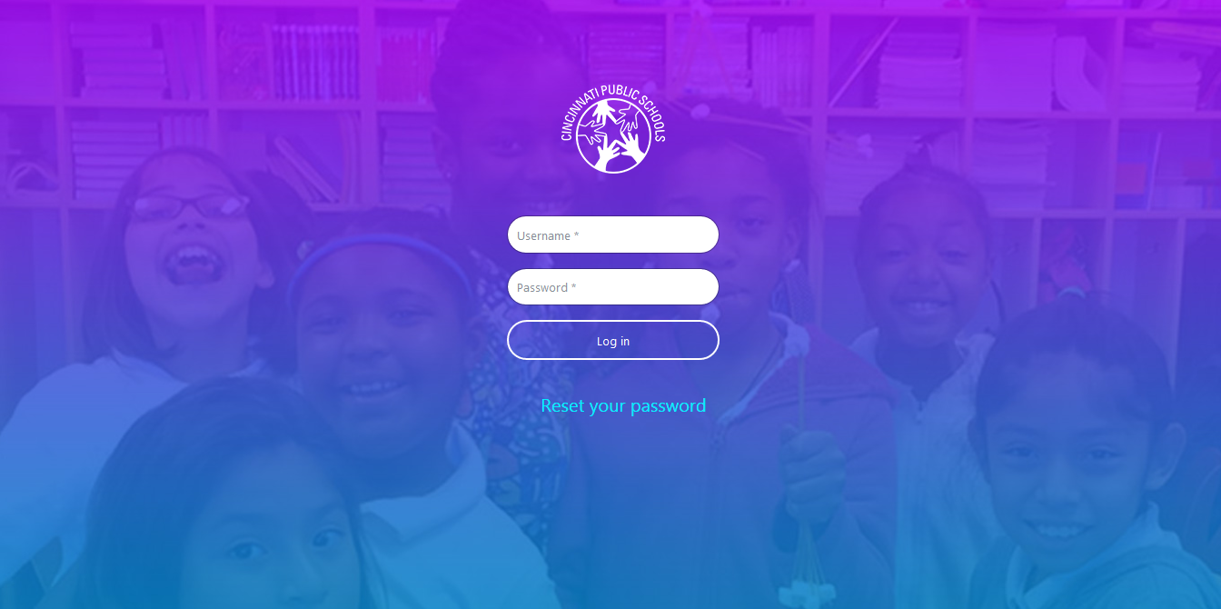

## Admin Dashboard:

When you log in as an Administrator, you can view the Newsfeeds posted by other Admin users, Students and Teachers on your Dashboard screen. You can also like posts, comment on posts, search for posts, delete posts, check notifications etc. You can also view the top 5 students’ list to the right of the screen.

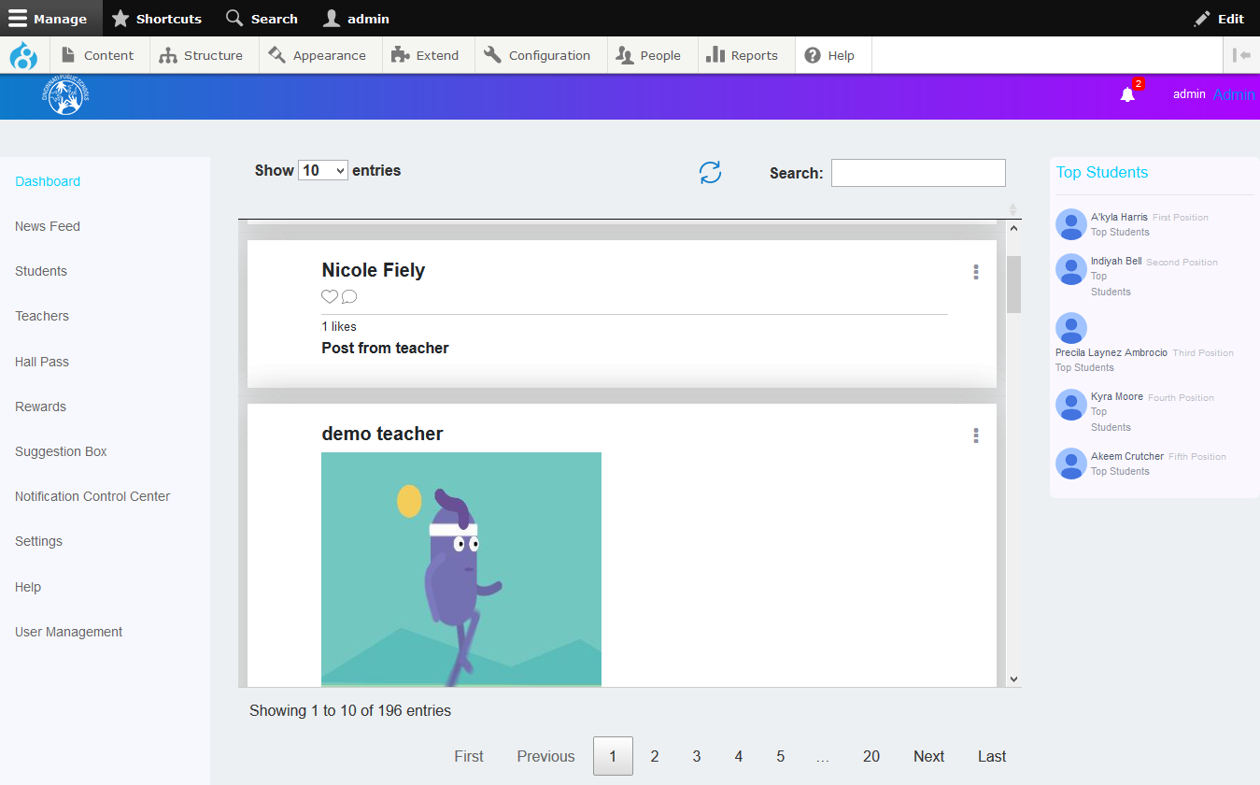

### Search:

Admin users can search for information on the dashboard page based on certain key words. There is a **Search** text box available at the top of the feeds. They can type in their keyword and the search result will be displayed below the **Search** text box based on the keyword typed in.

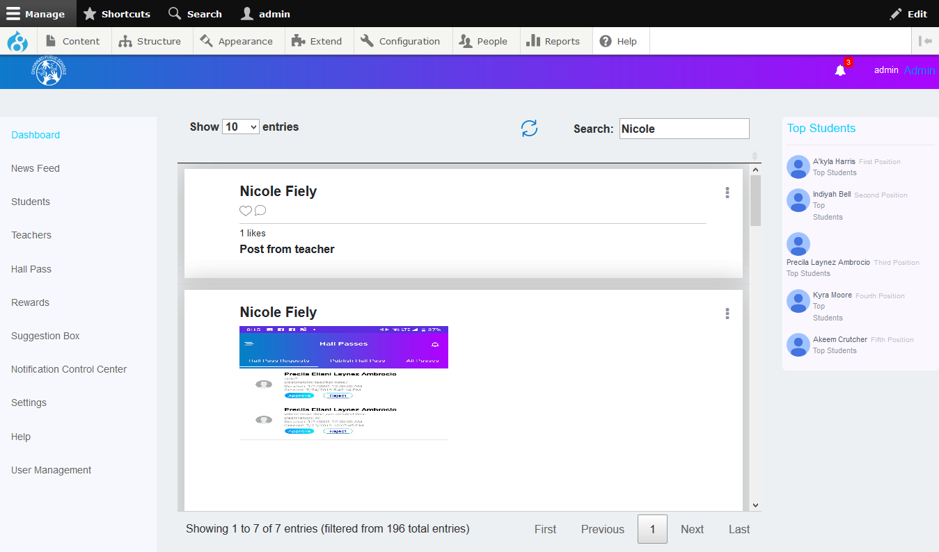

## Notifications:

The Notifications screen displays all the updates related to Students and Teachers. Click the bell icon displayed at the top of the Dashboard screen to access the Notifications screen. On this screen, you can view notifications such as new posts, hall pass requests, suggestions, and likes or comments which are created by Students and Teachers. You can click on any notification to access the details of that particular notification. You can view all notifications by clicking the **View All** link.

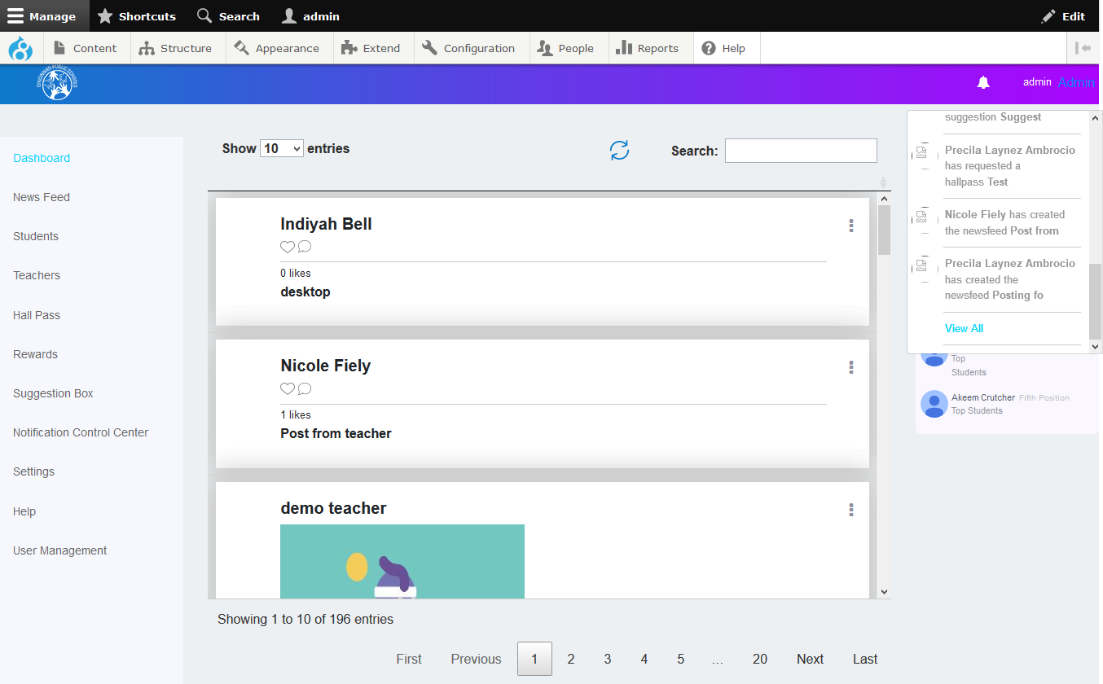

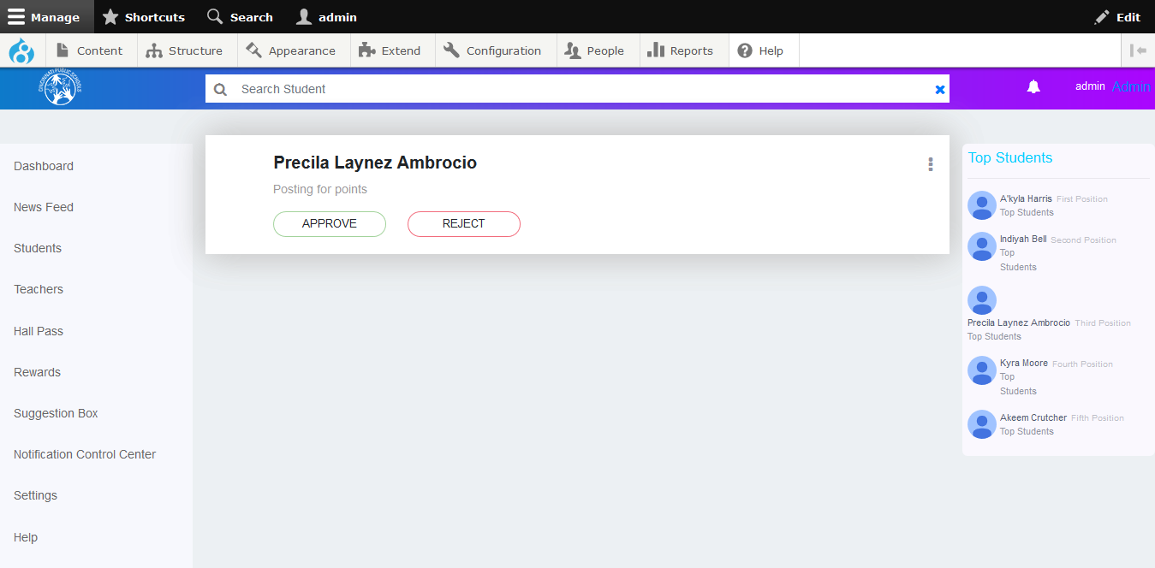

## Deleting Newsfeeds (Posts)

Admin users have the ability to delete newsfeeds or comment on particular newsfeeds.

**To delete a newsfeed:**

* Click on the newsfeed you want to delete.
* ON the newsfeed details window, click the  icon displayed at the top right corner of the newsfeed.
* Click the **Delete Newsfeed** button.

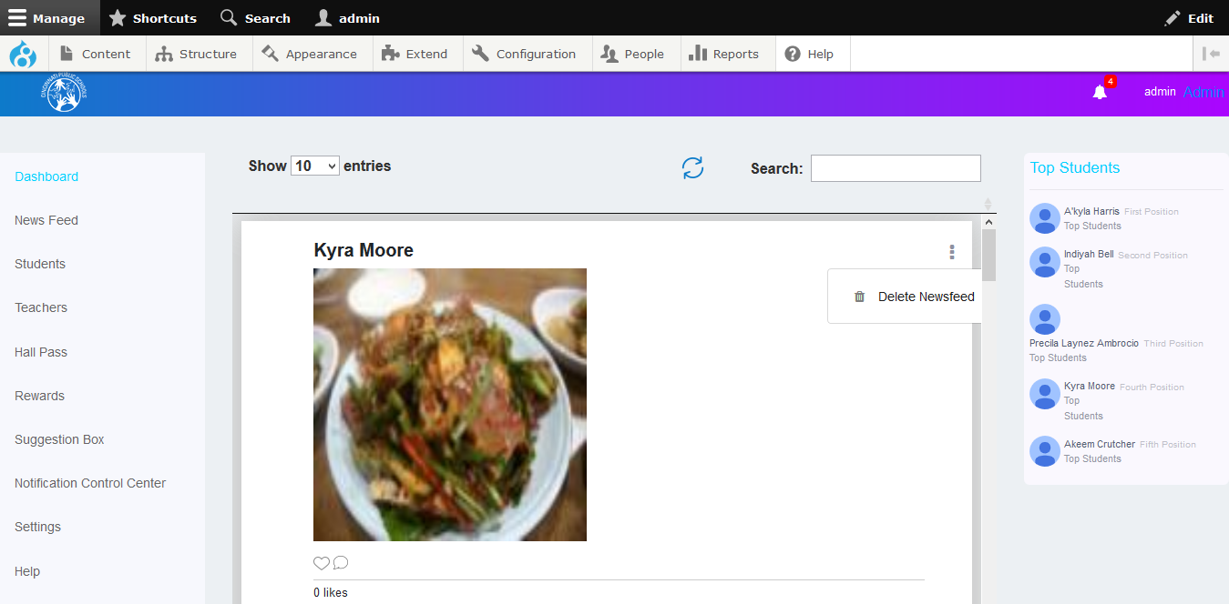

## Menu

There is a **Menu** displayed at the left side of the Dashboard screen. This menu displays all the screen and sections which you have access to. You can click the menu item you want to access and navigate to that particular screen.

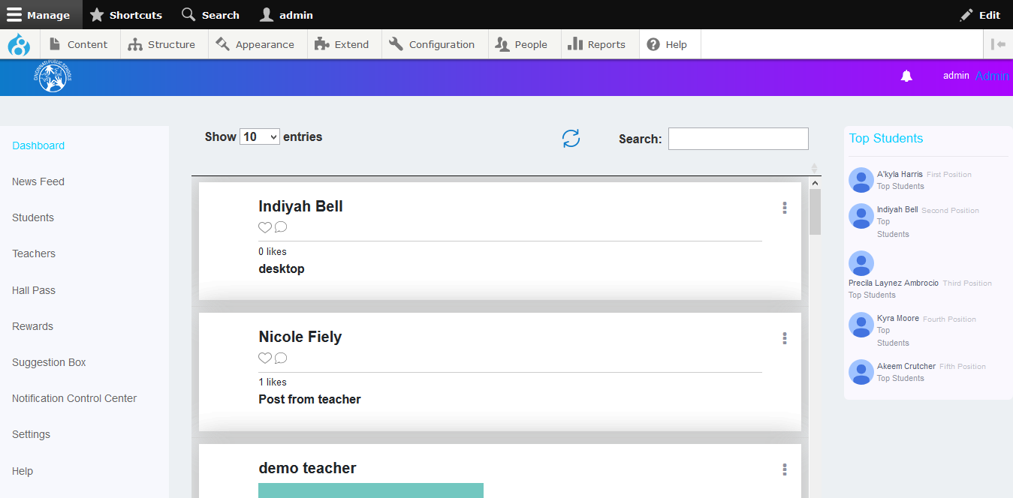

## Newsfeed

Admin users can view all the approved newsfeeds and comments posted by students and teachers. They can also create and post newsfeeds. On the Newsfeed screen, there are two tabs; **Newsfeed Approvals** and **Approve Comments**.

### Newsfeed Approvals tab

Admin users can view the Newsfeeds posted by Students and Teachers which are waiting to be approved. On this screen, you can approve or reject newsfeeds. You can also search for newsfeeds and approve, reject or delete them.

#### To approve newsfeeds:

* On the Newsfeed Approvals tab, select the newsfeed to be approved.
* Click the **Approve** button at the bottom of the newsfeed.

#### To reject newsfeeds:

* On the Newsfeed Approvals tab, select the newsfeed to be approved.
* Click the **Reject** button at the bottom of the newsfeed.

**Note:** The Students and Teachers associated with that newsfeed will receive a notification and a message from the administrator informing them of the approval or rejection of the newsfeed.

#### To delete newsfeeds:

* Click the icon displayed at the top right corner of the newsfeed.
* Click the **Delete Newsfeed** button.

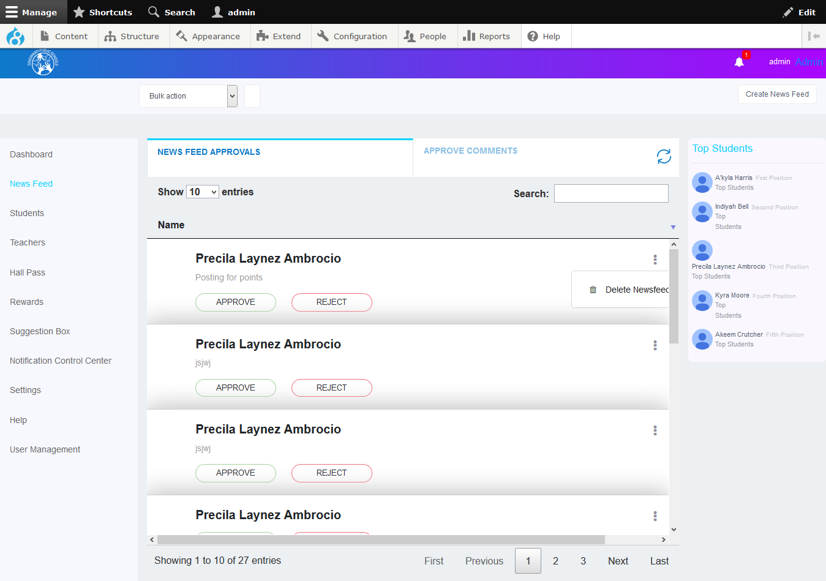

Click on ellipsis icon to delete Newsfeed

### Approve Comments tab

The Admin users can view all the comments which have been made on a particular newsfeed and approve or reject individual or multiple comments at once.

**To approve or reject multiple comments at once:**

* Select the corresponding checkboxes for the comments placed next to the comments.
* Click the **Approve** or **Reject** buttons below the comments list. .

**Note:** The users whose comments have been approved or rejected will receive a notification from the administrator informing them about the status of their comments.

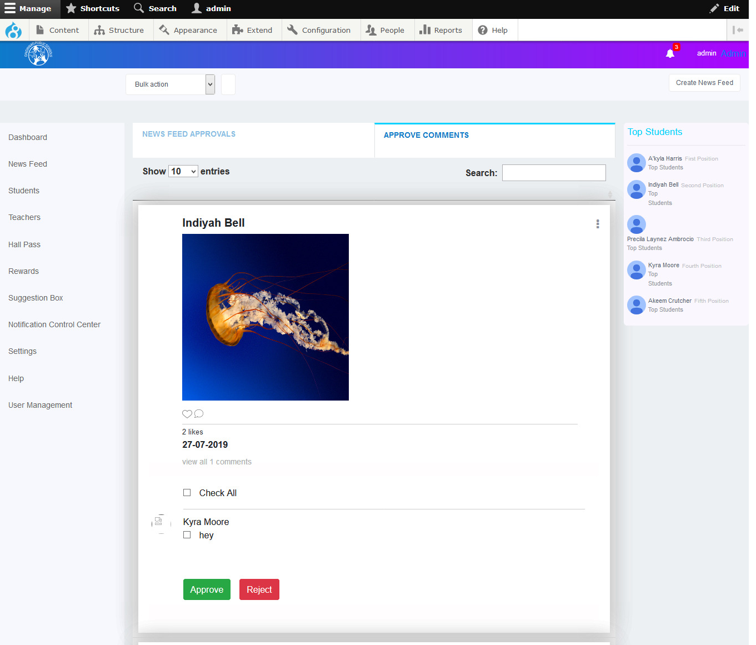

Click on ellipsis icon to delete Post With comments

Admin users can also publish a Newsfeed.

### To create a Newsfeed:

* Click the **Create News Feed** button at the top right corner of the Newsfeed screen. The Create Newsfeed window is displayed.

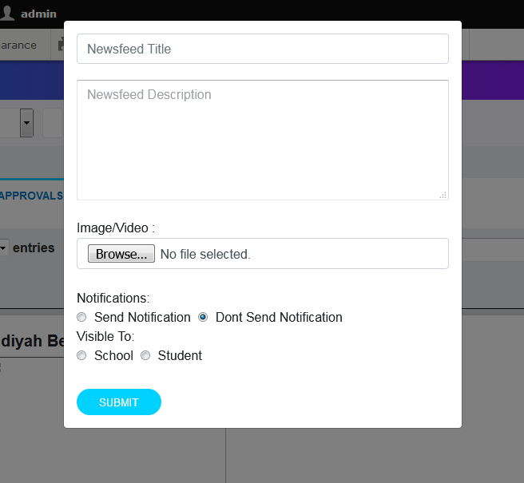

* Specify the title of the newsfeed and its description in the respective text boxes.
* Click the **Browse** button to upload an image or video if needed.
* Select the **Send Notification** radio button if you want so send a notification about the newsfeed to all students and teachers or select the **Don’t Send Notification** radio button if you do not want to send a notification to anyone.
* You can also choose to make the newsfeed visible to a set of schools. Select the **School** radio button under **Visible To** if you want to make the newsfeed visible to a particular school or a group of schools.

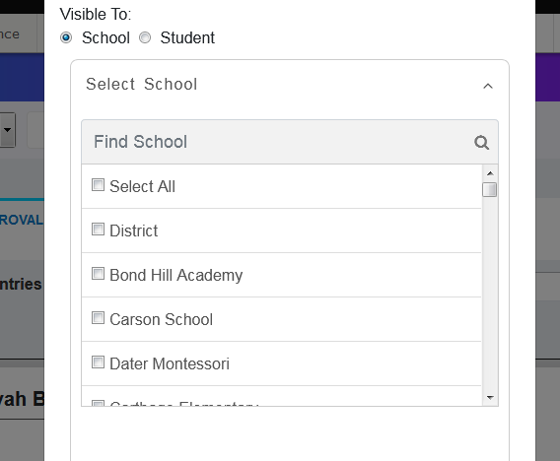

* Select the school or schools to which you want to make the newsfeed visible.

**Note:** You can also search for the particular school from the available list by typing in the name of that school and clicking the search icon.

* You can also choose to make the newsfeed visible to a particular set of schools based on their grades or upload a list of students. Select the **Student** radio button under **Visible To** if you want to make the newsfeed visible to a particular set of students as per their grades or to an uploaded list of students.

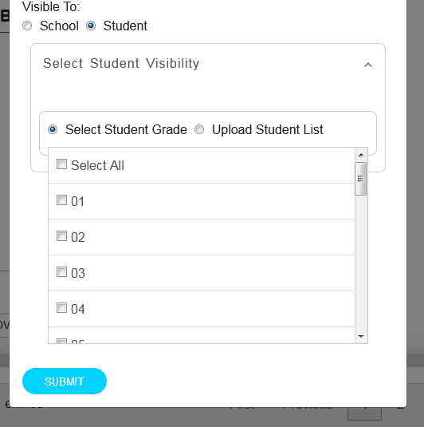

* Select the **Select Student Grade** radio button to select a grade. All the students who have achieved that grade will be able to view the newsfeed. Select the **Select All** option to make the newsfeed visible to students of all grades.

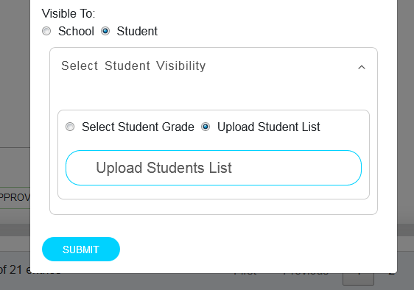

* Select the **Upload Student List** radio button to make the newsfeed visible to a particular set of students irrespective of their grades. Click the **Upload Students List** button to upload your list.
* Click the **Submit** button to create the newsfeed.

## Students:

All the information of Students is displayed in this screen. You can filter the information by School, Student Name & Student ID.

You can also search for a particular student.

**To search for a student**:

* Type in the student’s name in the **Search Student** text box
* Click the Search button. The details of the particular student are displayed.

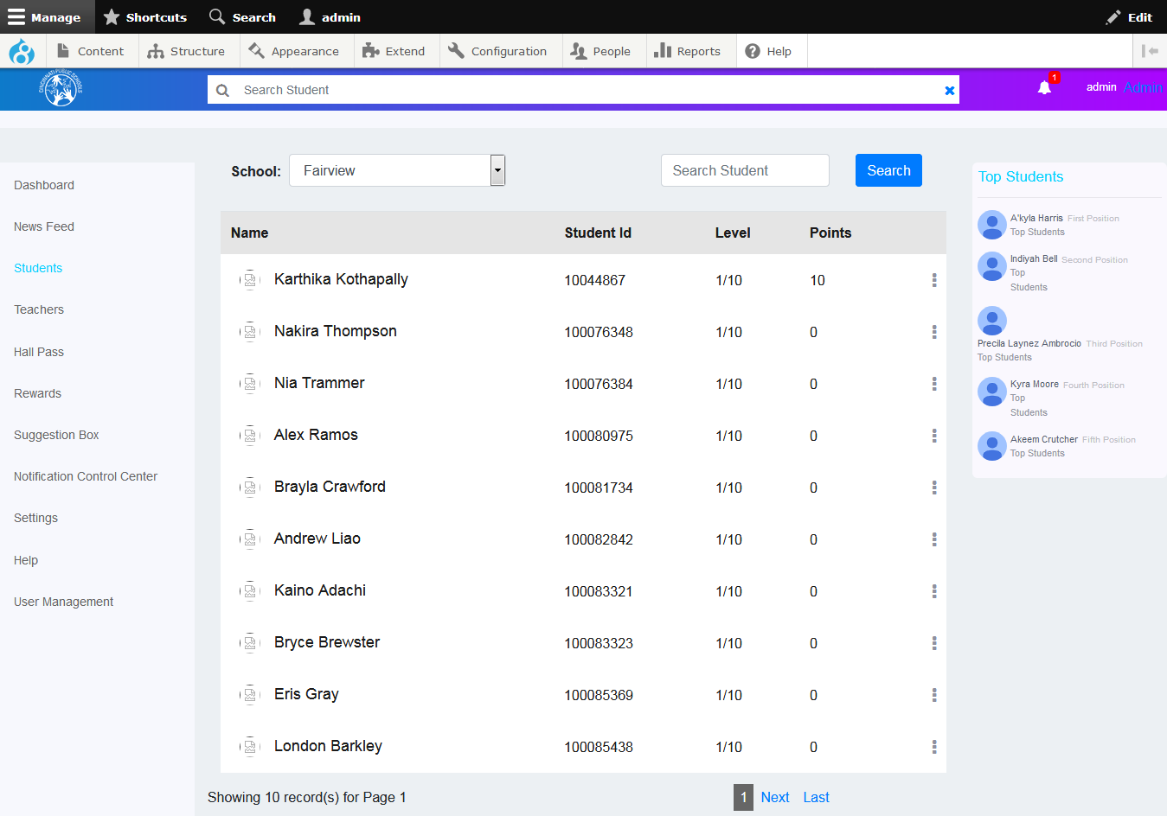

You can also edit the details of Students.

**To edit a student’s details:**

* Click the ellipsis icon as shown in the screen below.
* Click the **Edit Student** button.

### Edit Student

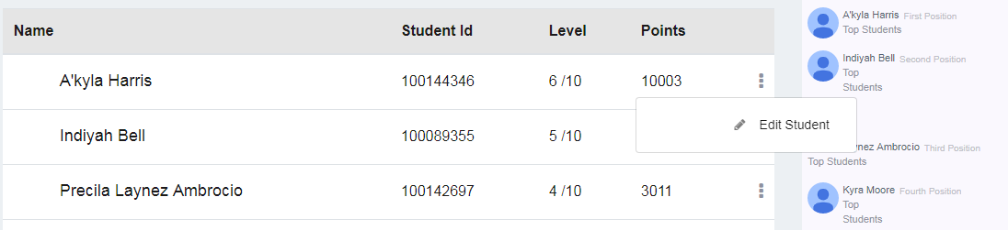

* The Edit Student window is displayed.

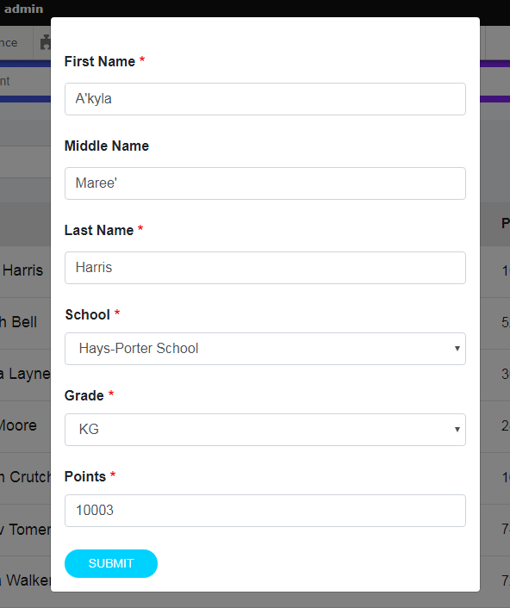

* In this window, you can edit the Student’s information such as First Name, Middle name, Last name, School, Grade and Points.
* Click the **Submit** button to save your changes.

Teachers: (Future Implementation)

## Hall Pass

In the Hall Pass screen, you can view the hall pass requests from the Students, and can approve or reject the hall passes. There are two tabs in this screen; Published Hall Passes and Hall Pass Requests.

### Published Hall Passes tab

The Published Hall Passes tab displays all the hall passes that have a status associated with them. You can view the details of the hall passes such as approved by, validity and destination hall.

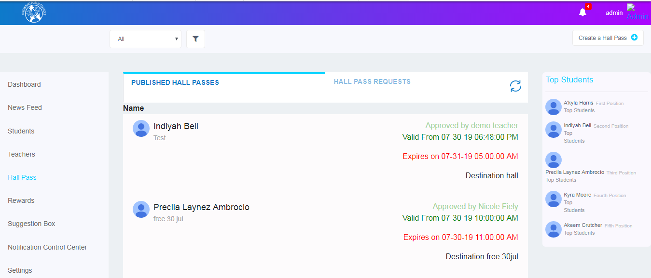

### Hall Pass Requests tab

In thistab, you can view all the hall pass requests along with their information such as description, destination, valid from, expires on etc. You can approve or reject a hall pass.

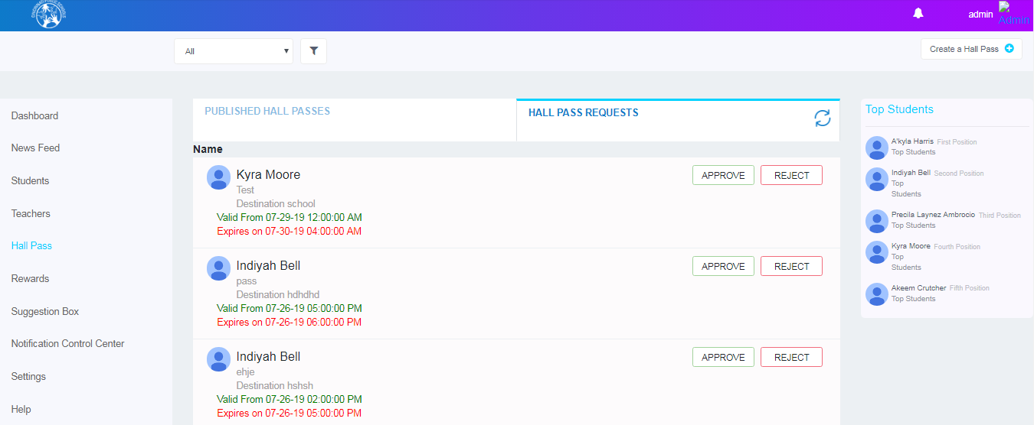

#### To approve or reject a hall pass:

* Select the hall pass from the list.
* Click the **Approve** or **Reject** buttons to approve or reject the hall pass.

You can also create and approve a hall pass for a Student.

### To creating a New Hall Pass:

* Click the Create a Hall Pass button at the top right corner of the Hall Passes screen. Create Hall Pass window is displayed.

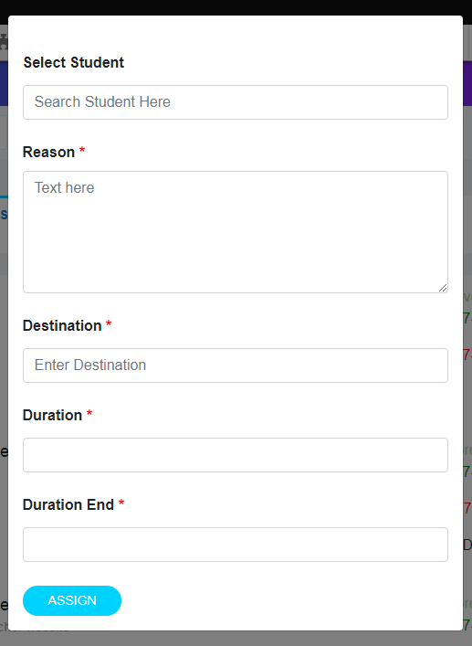

* Select the Student by searching for the student.
* Specify the reason and description in the respective text boxes.
* Specify the destination where the hall pass is to be used.
* Mention the start date and end date of the hall pass in the **Duration Start** and **Duration End** fields.
* click the **Assign** button to publish a hall pass for the Student.

## Rewards:

There are three tabs in the Rewards screen; Available Rewards, Assign Points and Assign Rewards for Action.

### Available Rewards tab

You can view the list of all the students who have rewards. Click on the Number under the Reward level to view their details.

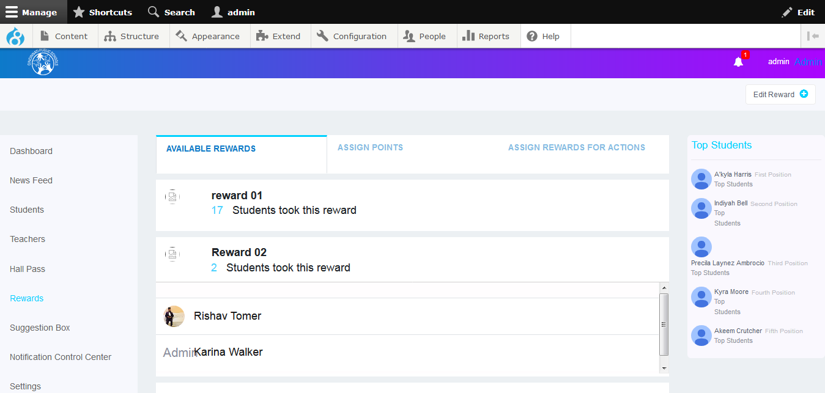

### Assign Points Tab

You can assign points to a single student or multiple students.

**To assign points to a single student:**

* Select the **For Single Student** radio button to assign rewards to a single student.
* Search for the student in the Select Student search field, assign the number of points and mention the reason for assigning the rewards.
* Click the **Assign** button.

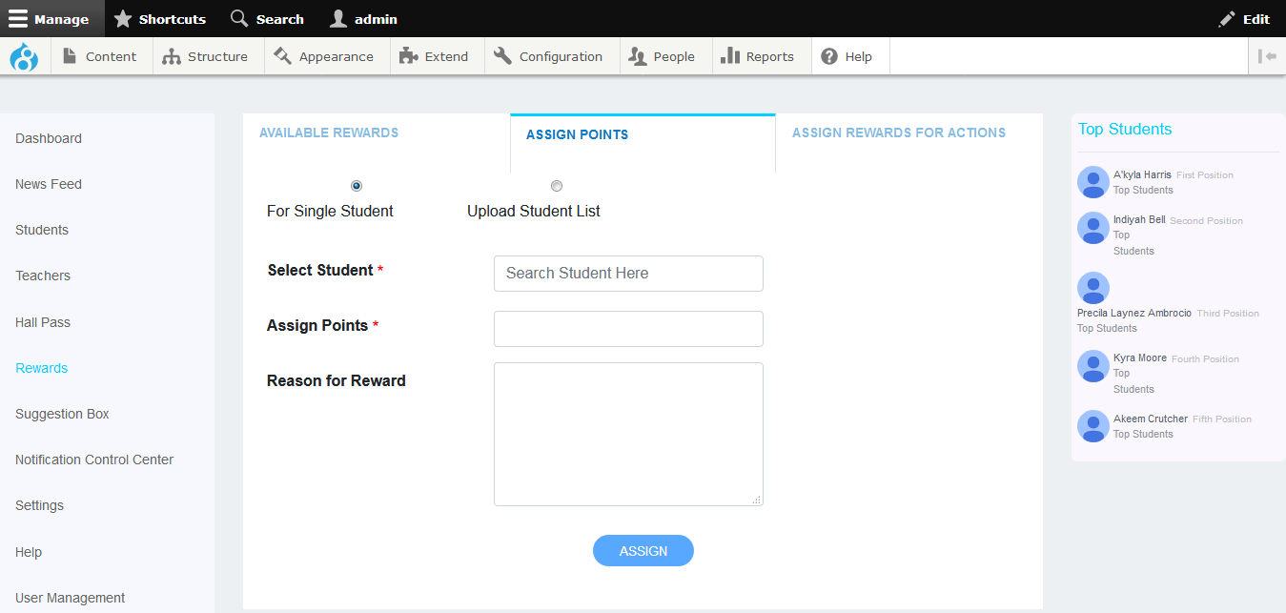

**To assign points to multiple students:**

* Select the **Upload Student List** radio button.
* Browse for the rewards file by clicking the Browse button.
* Click the **Submit** button.

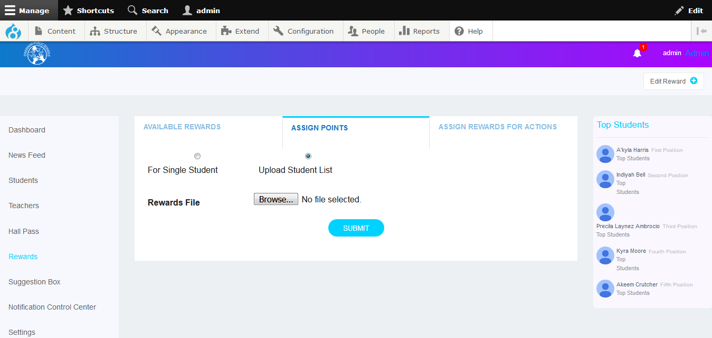

### Assign Rewards for Action Tab

You can assign bonus points for actions like News Feed Approval, Hall Pass Approvals, Delete Post, Like Post, Posting Comment Approval, Suggestion Comments Approval, Suggestion Like Post and Suggestions Feed Approval.

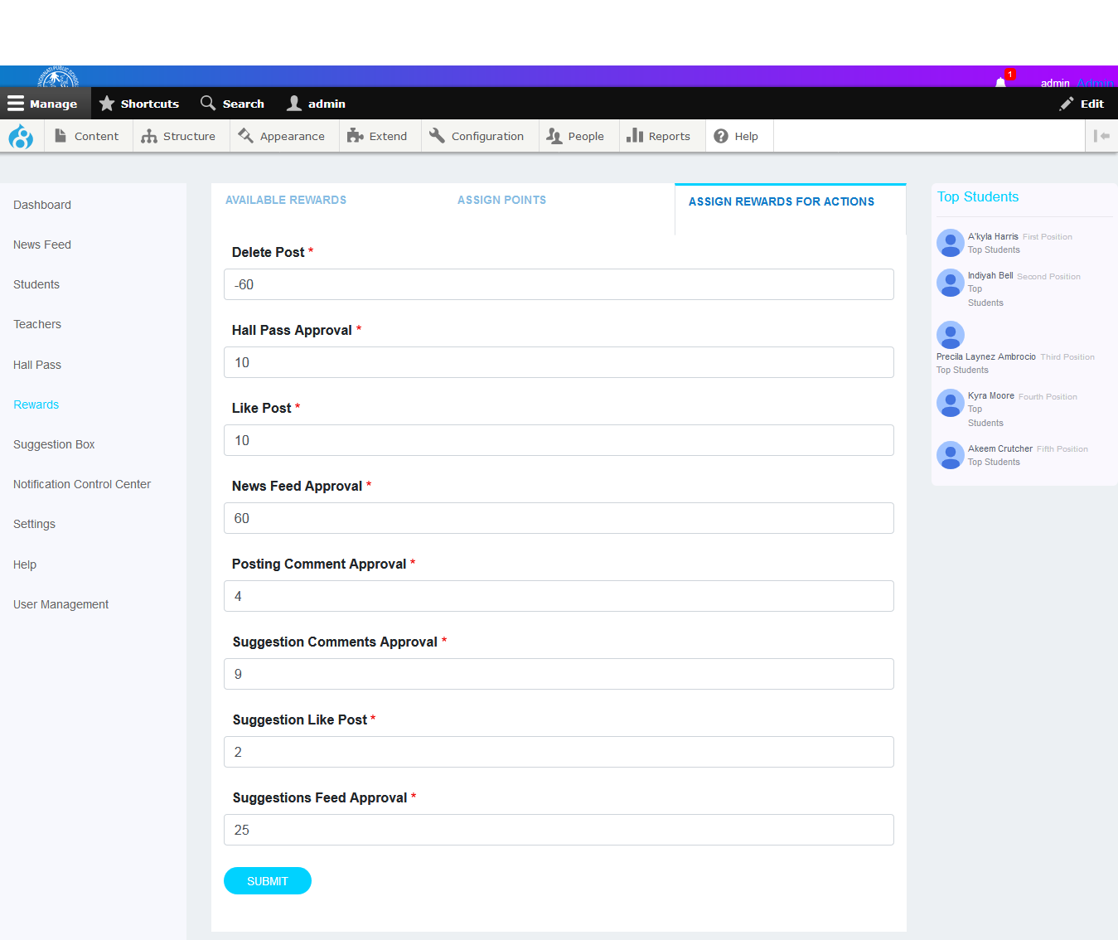

Suggestions Box: (Future Implementation)

Notification Control Center: (Future Implementation)

Settings: (Future Implementation)

## Help

From this screen, you can describe the various categories such as News Feeds, Notifications and Rules etc. These descriptions will be displayed the respective Student and Teacher Dashboard Help screens.

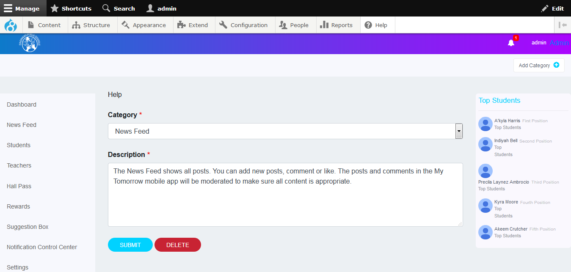

You can add a new Category from this screen.

**To add a new category:**

* Click the Add Category button which is at the top right corner of the screen.
* The Add Category window is displayed.
* Mention the name of the category and its description.
* Click the **Assign** button.

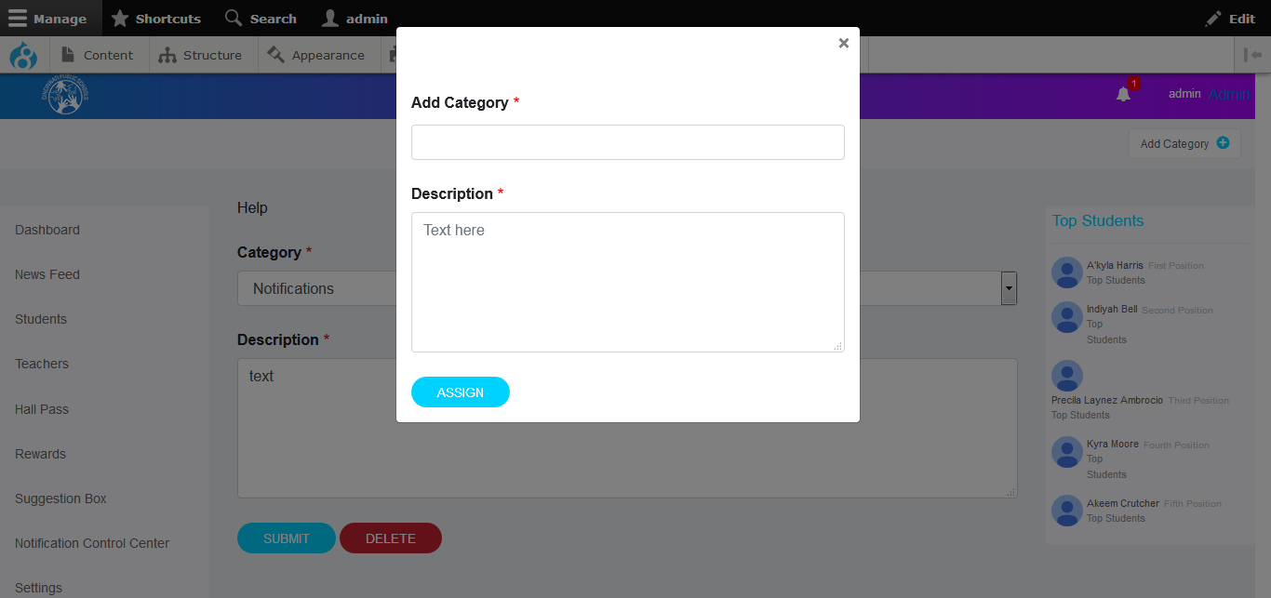

You can also delete a certain category.

**To delete a category:**

* Select the category from the **Category** drop-down list in the Help screen.
* Click the Delete button below the **Description** text box.

# User Management: (Future Implementation)